June 2020-Jan 2021

June 11 2020 to Jan11 2021



BIRDS OF STAFF COLLEGE, GUWAHATI

**Internship Report**

Supervisor-

Mr Udayan Borthakur

Submitted by-

Urjit Dwivedi

Preface

The objective of the internship was to record and characterize the bird species found in the staff college, Khanapara, Guwahati. I have been studying birds in surrounding area for the last 2- years . During last 6 months I have updated and finalised the checklist extensively. 59 bird species were found during survey. I have prepared the final document regarding the internship, the document contains all the bird species found in staff college, descriptions about their characteristic features and recorded photographs . I have worked extensively on this project and surveyed the area around staff college , Where I have found 59 different bird species ,The photos of the bird are attached , of which most of them are taken by me , but some are taken from other sources . The description about their characteristics is taken from online sources like Wikipedia . I have also prepared a checklist of bird species with their scientific name, Common name , Family and Status .I have written extensively about their habitats and their bird calls as well as described what makes every species so unique. Doing this project was a great experience for me and I learned a-lot during the process .

CCHECKLIST

**List of Acronyms**

C – Common

CR – Critially Endangered

EN - Endangered

EW – Extinct in the Wild

EX – Extinct

IUCN – International Union for Conservation of Nature

LC – Least Concerned

NT – Near Threatened

R – Resident

VU - Vulnerable

WM – Winter Migrant

**Table: Checklists of birds sighted at the Assam Administrative Staff College Campus, Guwahati.**

|  |  |  |  |  |  |  |  |  |  |  |  |
| --- | --- | --- | --- | --- | --- | --- | --- | --- | --- | --- | --- |
| **Sl.**  **No.** | | **Family** | **Common Name** | | **Scientific name** | | | | **Statu s** | | |
| 1 | | Ciconnidae | Asian Openbill | | *Anastomus oscitans* | | | | R, C | | |
| 2 | | Ardeidae | Cattle Egret | | *Bulbulcus ibis* | | | | R, C | | |
|  | |  | Intermediate Egret | | *Ardea interme dia* | | | | R, C | | |
| 3 | | Accipitridae | Black Kite | | *Milvus migrans* | | | | R, r | | |
|  | |  | White-rumped Vulture | | *Gyps bengale nsis* | | | | CREN  ,  R, r | | |
| 4 | | Rallidae | White  -breasted Waterhen | | *Amaurornis phoenicurus* | | | | R, C | | |
| 5 | | Columbidae | Yellow-footed Green Pigeon | | *Treron phoenicoptera* | | | | R, C | | |
|  | |  | Spotted Dove | | *Streptop elia chinensi s* | | | | R, C | | |
| 6 | | Psittacidae | Rose-ringed Parakeet | | *Psittacula krameri* | | | | R, C | | |
| 7 | | Cuculidae | Common hawk Cuckoo | | *Heirococcyx varius* | | | | R, r | | |
|  | |  | Eurasian Cuckoo | | *Cuculus canorus* | | | | R, C | | |
|  | |  | Asian Koel | | *Eudyna mys scolopa cea* | | | | R, C | | |
|  | |  | Greater Coucal | | *Centropus sinensis* | | | | R, C | | |
| 8 | | Strigidae | Spotted Owlet | | *Athene brama* | | | | R, C | | |
|  | |  | Asian Barred Owlet | | *Glaucidi um cuculoid es* | | | | R, r | | |
|  | |  | Brown Hawk-owl | | *Ninox scutulat a* | | | | R, C | | |
| 10 | | Apodidae | House Swift | | *Apus affinis* | | | | R, C | | |
| 11 | | Coraciidae | Indian Roller | | *Coracias benghalen sis* | | | | R, C | | |
| 12 | | Alcedinidae | White | | *Halycyo* | | | | R, C | | |
|  | |  | breasted | | *n* | | | |  | | |
|  | |  | Kingfisher | | *smyrens* | | | |  | | |
|  | |  |  | | *is* | | | |  | | |
|  | |  | | | Common King- fisher | | *Alcedo atthis* | | R, C | | | |
| 13 | | Meropidae | | | Blue- tailed Bee- eater | | *Merops philippi nus* | | R, C | | | |
| 14 | | Upupidae | | | Hoopoe | | *Upupa epops* | | R, C | | | |
| 15 | | Bucerotidae | | | Oriental Pied Hornbill | | *Anthracoc eros albrostris* | | R, C | | | |
|  | |  | | | Great Hornbill | | *Buceros bicornis* | |  | | | |
| 16 | | Megalaimida e | | | Coppersmith Barbet | | *Megalaima haemocephala* | | R, C | | | |
|  | |  | | | Blue-throated Barbet | | *Megalaima asiatica* | | R, C | | | |
| 17 | | Picidae | | | Fulvous- breasted Woodpecker | | *Dendrocopos macei* | | R, r | | | |
|  | |  | | | Himalay an Flameba ck | | *Dinopium shorii* | | R, C | | | |
| 18 | | Lanidae | | | Grey-backed Shrike | | *Lanius tephronot us* | | R, r | | | |
| 19 | | Motacillidae | | | White Wagtail | | *Motacilla alba* | | WM, C | | | |
|  | |  | | | Paddyfield Pipit | | *Anthus rufulus* | | WM, C | | | |
| 20 | | Paridae | | | Cenereous Tit | | *Parus major* | | R, C | | |
| 21 | | Timaliidae | | | Jungle Babbler | | *Turdoides striatus* | | R, C | | |
|  | |  | | | Common Tailor- bird | | *Orthotomus sutorius* | | R, C | | |
| 22 | | Phyllocopida e | | | Greenish Warbler | | *Phylloscopus trochiloides* | | WM, r | | |
| 23 | | Muscicapida e | | | Grey-headed Canary Flycatcher | | *Culicica pa ceylone nsis* | | R, r | | |
|  | |  | | | Siberian StoneChat | | *Saxicola maurus* | | WM, C | | |
|  | |  | | | Magpie Robin | | *Copsychus saularis* | | R, C | | |
|  | |  | | | Hodgson’s Redstart | | *Phoenicurus auroreus* | | WM, r | | |
| 24 | | Pycnonotida e | | | Red-vented Bulbul | | *Pycnonotus cafer* | | R, C | | |
| 25 | | Saturnidae | Common Myna | | *Acridotheres tristis* | | R, C | | |
|  | |  | Pied Myna | | *Gracupia contra* | | R, C | | |
|  | |  | Jungle Myna | | *Acridotheres fuscus* | | R, C | | |
|  | |  | Chestnut-tailed Starling | | *Sturnus malabaric us* | | R, C | | |
|  | |  | Hill Myna | | *Gracula religios a* | | R, r | | |
| 25 | | Oriolidae | Black-headed Oriole | | *Oriolus xanthornu s* | | R, C | | |
| 26 | | Dicruridae | Black Drongo | | *Dicrurus macroce rcus* | | R, r | | |
|  | |  | Spangled Drongo | | *Dicrurus hottentott us* | | R, C | | |
| 27 | | Corvidae | Rufous Treepie | | *Dendrocitta vagabunda* | | R, r | | |
|  | |  | Common Crow | | *Corvus splende ns* | | R, C | | |
| 28 | | Passeridae | House Sparrow | | *Passer domesti cus* | | R, C | | |
| 29 | | Zosteropidae | Oriental White- eye | | *Zosterops palpebrosus* | | R, C | | |
| 30 | | Estrildidae | Scaly-breasted Munia | | *Lonchu ra punctul ata* | | R, C | | |
| 31 | | Dicacidae | Scarlet- backed Flowerpecke r | | *Dicaeum cruentatu m* | | R, C | | |
| 32 | | Nectariniida e | Crimson Sunbird | | *Aethopyga siparaja* | | R, C | | |
|  | |  | Purple Sunbird | | *Cinnyris asiaticu s* | | R, C | | |
|  | |  | Little Spiderhunter | | *Arachnot hera longirostr a* | | R, C | | |
| 33 | | Falconidae | Common Kestrel | | *Falco tinnunc ulus* | | R, C | | |
| 34 | | Charadriidae | Red-wattled Lapwing | | *Vanellus indicus* | | R, C | | |

# 1. Asian Openbill

The Asian openbill or Asian openbill stork (*Anastomus oscitans*) is a large wading bird in the stork family Ciconiidae.This distinctive stork is found mainly in the Indian subcontinent and Southeast Asia. It is greyish or white with glossy black wings and tail and

the adults have a gap between the arched upper mandible and recurved lower mandible. Young birds are born without this gap which is thought to be an adaptation that aids in the handling of snails, their main prey.

Although resident within their range, they make long distance movements depending on conducive weather and food availability.

The usual foraging habitats are inland wetlands and are only rarely seen along river banks and tidal flats. On agricultural landscapes, birds forage in crop fields, irrigation canals, and in seasonal marshes. Birds may move widely in response to habitat conditions.Young birds also disperse widely after fledging.

Individuals ringed at Bharatpur in India have been recovered 800 km east and a bird ringed in Thailand has been recovered 1500 km west in Bangladesh. Storks are regularly disoriented by lighthouses along the southeast coast of India on overcast nights betweenAugust and September.The species is very rare in the Sind and Punjab regions of Pakistan, but widespread and common in India, Sri Lanka, Burma and Thailand.

During the warmer part of the day, Asian Openbills soar on thermals and have a habit of descending rapidly into their feeding areas. Groups may forage together in close proximity in shallow water or marshy ground on which they may walk with a slow and steady gait.

The breeding season is after the rains, during July to September in northern India and Nepal, and November to March in southern India and Sri Lanka.They may skip breeding in drought years.

In colonial India, sportsmen shot the Openbill for meat, calling it the ‘beef-steak bird’.

## Conservation status

Extinct

EX EW

Threatned

CR EN VU

Least Concern

NT LC

3

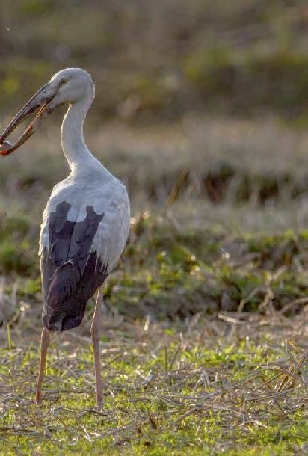

Least Concern (IUCN 3.1)

**Scientific classification** Kingdom: Animalia

Phylum: Chordata

Class: Aves

Order: Ciconiiformes

Family: Ciconiidae

Genus: Anastomus

Species: *A. oscitans*

Photograph: Urjit Dwivedi

# 2. Cattle Egret

The cattle egret (*Bubulcus ibis*) is a cosmopolitan species of heron (family Ardeidae) found in the tropics, subtropics and warm temperate zones. It is the only member of the monotypic genus *Bubulcus*, although some authorities regard two of its subspecies as full species, the western cattle egret and the eastern cattle egret. Despite the similarities in plumage to the egrets

of the genus *Egretta*, it is more closely related to the herons of *Ardea*. Originally native to parts of Asia,Africa and Europe, it has undergone a rapid expansion in its distribution and successfully colonized much of the rest of the world in the last century.

It is a white bird adorned with buff plumes in the breeding season. It nests in colonies, usually near bodies of water and often with other wading birds. The nest is a platform of sticks in trees

or shrubs. Cattle egrets exploit drier and open habitats more than other heron species. Their feeding habitats include seasonally inundated grasslands, pastures, farmlands, wetlands and rice paddies. They often accompany cattle or other large mammals, catching insect and small vertebrate prey disturbed by these animals. Some populations of the cattle egret are migratory and others show post-breeding dispersal.

The adult cattle egret has few predators, but birds or mammals may raid its nests, and chicks may be lost to starvation, calcium deficiency or disturbance from other large birds. This species maintains a special relationship with cattle, which extends to other large grazing mammals; wider human farming is believed to be a major cause of their suddenly expanded range. The cattle egret removes ticks and flies from cattle and consumes them. This benefits both species, but it has been implicated in the spread of tick-borne animal diseases.

## Conservation status

Extinct Threatned

EX EW CR EN VU

Least Concern

NT LC

5

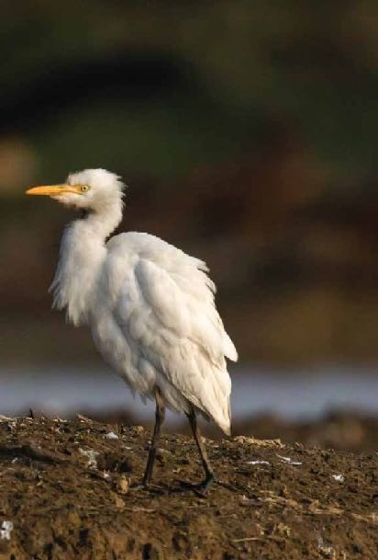

Least Concern (IUCN 3.1)

**Scientific classification** Kingdom: Animalia Phylum: Chordata

Class: Aves

Order: Pelecaniformes

Family: Ardeidae

Genus: Bubulcus

Species: *B. ibis*

Photograph: Urjit Dwivedi

# 3.Intermediate Egret

The intermediate egret, median egret, smaller egret, or yellow- billed egret (Ardea intermedia) is a medium-sized heron. Some taxonomists put the species in the genus Egretta or Mesophoyx. It is a resident breeder from east Africa across the Indian subcontinent to Southeast Asia and Australia.

This species, as its scientific name implies, is intermediate in size between the great egret and smaller white egrets like the little egret and cattle egret, though nearer to little than great.

The intermediate egret stalks its prey methodically in shallow coastal or fresh water, including flooded fields. It eats fish, frogs, crustaceans and insects. It often nests in colonies with other herons, usually on platforms of sticks in trees or shrubs. Two to five eggs are laid, the clutch size varying with region.

## Conservation status

Extinct

EX EW

Threatned

CR EN VU

Least Concern

NT LC

Least Concern (IUCN 3.1)

**Scientific classification** Kingdom: Animalia Phylum: Chordata

Class: Aves

Order: Ciconiiformes

Family: Ciconiidae

Genus: Anastomus

Species: *A. oscitans*

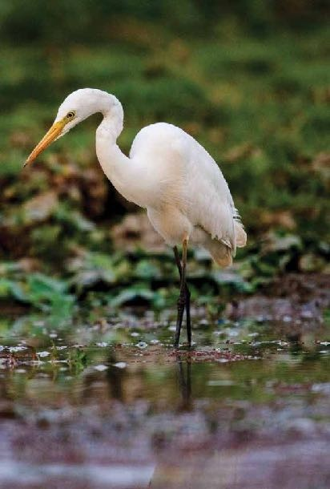

7

# 4. Black Kite

The black kite(*Milvusmigrans*) -sized bird of prey in the family Accipitridae, which also includes many other diurnal raptors. It is thought to be the world's most abundant species

of Accipitridae, although some populations have experienced dramatic declines or fluctuations. Current global population estimates run up to 6 million individuals.[1] Unlike others of the group, black kites are opportunistic hunters and are more likely to scavenge. They spend a lot of time soaring and gliding in thermals in search of food. Their angled wing and distinctive forked tail make them easy to identify. They are also vociferous with a

shrill whinnying call. This kite is widely distributed through the temperate and tropical parts of Eurasia and parts of Australasia and Oceania, with the temperate region populations tending to be migratory. Several subspecies are recognized and formerly had their own English names. The European populations are small, but the South Asian population is very large.

The species is found in Europe,Asia,Africa andAustralia.The temperate populations of this kite tend to be migratory while the tropical ones are resident. European and central Asian birds are migratory, moving to the tropics in winter, but races in warmer regions. In some areas such as in the United Kingdom, the black kite occurs only as a wanderer on migration.

Black kites are most often seen gliding and soaring on thermals as they search for food. The flight is buoyant and the bird glides with ease, changing directions easily.They will swoop down with their legs lowered to snatch small live prey, fish, household refuse

and carrion.

## Conservation status

Extinct Threatned

EX EW CR EN VU

Least Concern

NT LC

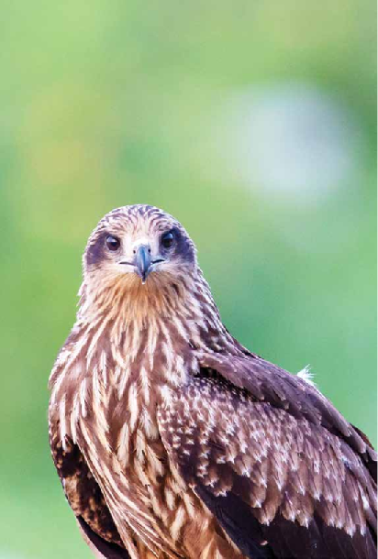

Least Concern (IUCN 3.1)

**Scientific classification** Kingdom: Animalia Phylum: Chordata

Class: Aves

Order: Accipitriformes

Family: Accipitridae

Genus: Milvus Species: *M. migrans*

# 11.White Rumped Vulture

TheWhite-Rumped Vulture(*Gypsbengalensis*) is an Old World vulture native to South and Southeast Asia. It has been listed as Critically Endangered on the IUCN Red Listsince 2000, as the population severely declined.White-rumped vultures die of renal failure caused by diclofenac poisoning. In the 1980s, the global population was estimated at several million individuals, and it was thought to be "the most abundant large bird of prey in the world". As of 2016, the global population was estimated at less than 10,000 mature individuals.

12

The white-rumped vulture is a typical, medium-sized vulture, with an unfeathered head and neck, very broad wings, and short tail feathers. It is much smaller than the Eurasian Griffon. It has a white neck ruff. The adult's whitish back, rump, and underwing coverts contrast with the otherwise dark plumage. The body is black and the secondaries are silvery grey. The head is tinged in pink and bill is silvery with dark ceres. The nostril openings are slit-like. Juveniles are largely dark and take about four or five years to acquire the adult plumage. In flight, the adults show a dark leading edge of the wing and has a white wing-lining on the underside. The undertail coverts are black.

This is the smallest of the *Gyps* vultures, but is still a very large bird. It weighs 3.5-7.5 kg (7.7-16.5 lbs), measures 75–93 cm (30–37 in) in length,

[4] and has a wingspan of 1.92–2.6 m (6.3–8.5 ft).

This vulture builds its nest on tall trees often near human habitations in northern and central India, Pakistan, Nepal, Bangladesh and southeastAsia, laying one egg. Birds form roost colonies. The population is mostly resident.

Like other vultures it is a scavenger, feeding mostly from carcasses of dead animals which it finds by soaring high in thermals and spotting other scavengers. It often moves in flocks. At one time, it was the most numerous of the vultures in India.

## Conservation status

Extinct

EX EW

Threatned

CR EN VU

Least Concern

NT LC

13

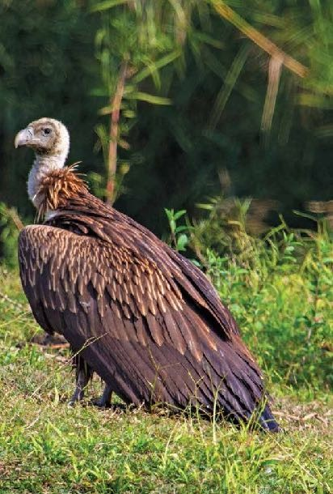

Critically Endangered (IUCN 3.1)

**Scientific classification** Kingdom: Animalia Phylum: Chordata

Class: Aves

Order: Accipitriformes

Family: Accipitridae

Genus: *Gyps*

Species: *G. bengalensis*

Photograph: Urjit Dwivedi

# 6. Common Kestrel

The **common kestrel** (*Falco tinnunculus*) is a bird of prey species belonging to the kestrel group of the falcon family Falconidae. It is also known as the **European kestrel**, **Eurasian kestrel**, or **Old World kestrel**. In Britain, where no other kestrel species occurs, it is generally just called “the **kestrel**”.

14

This species occurs over a large range. It is widespread in Europe, Asia, and Africa, as well as occasionally reaching the east coast of North

America. It has colonized a few oceanic islands, but vagrant individuals are generally rare; in the whole of Micronesia for example, the species was only recorded twice each on Guam and Saipan in the Marianas.

Common kestrels measure 32–39 cm (13–15 in) from head to tail, with a wingspan of 65–82 cm (26–32 in). Females are noticeably larger, with the adult male weighing 136–252 g (4.8–8.9 oz), around 155 g (5.5 oz) on average; the adult female weighs 154–314 g (5.4–

11.1 oz), around 184 g (6.5 oz) on average. They are thus small compared with other birds of prey, but larger than most songbirds. Like the other *Falco* species, they have long wings as well as a distinctive long tail.

Their plumage is mainly light chestnut brown with blackish spots on the upperside and buff with narrow blackish streaks on the underside; the remiges are also blackish. Unlike most raptors, they display sexual colour dimorphism with the male having fewer black spots and streaks, as well as a blue-grey cap and tail. The tail is brown with black bars in females, and has a black tip with a narrow white rim in both sexes. All common kestrels have a prominent black malar stripe like their closest relatives.

The cere, feet, and a narrow ring around the eye are bright yellow; the toenails, bill and iris are dark. Juveniles look like adult females, but the underside streaks are wider; the yellow of their bare parts is paler. Hatchlings are covered in white down feathers, changing to a buff-grey second down coat before they grow their first true plumage.

## Conservation status

Extinct

EX EW

Threatned

CR EN VU

Least Concern

NT LC

15

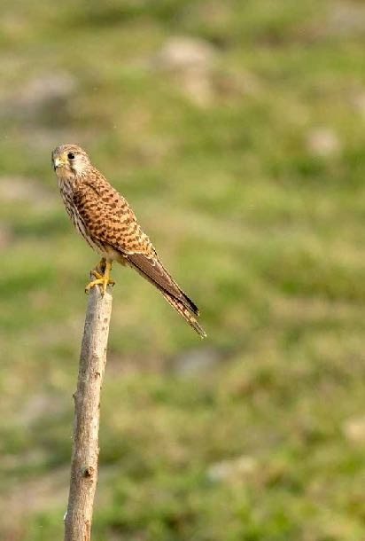

Least Concern (IUCN 3.1)

**Scientific classification** Kingdom: Animalia

Phylum: Chordata

Class: Aves

Order: Falconiformes

Family: Falconidae

Genus: *Falco*

Species: *F. tinnunculus*

Photograph: Urjit Dwivedi

# 7. White- breasted Waterhen

The White-breasted waterhen (*Amaurornis phoenicurus*) is a waterbird of the rail and crake family, Rallidae, that is widely distributed across Southeast Asia and the Indian Subcontinent. They are dark slaty birds with a clean white face, breast and belly. They are somewhat bolder than most other rails and are often seen stepping slowly with their tail cocked upright in open marshes or even drains near busy roads. They are largely

crepuscular in activity and during the breeding season, just after the first rains, make loud and repetitive croaking calls.

Adult white-breasted waterhens have mainly dark grey upperparts and flanks, and a white face, neck and breast. The lower belly and undertail are cinnamon coloured. The body is flattened laterally to allow easier passage through the reeds or undergrowth. They have long toes, a short tail and a yellow bill and legs. Sexes are similar but females measure slightly smaller.

Their breeding habitat is marshes across tropical Asia from Pakistan east to Indonesia. They are mainly seen in the plains but have been known from the higher hills such as in Nainital

(1300m) and the High Range (1500m) in Kerala.These large 32 cm long rails are permanent residents throughout their range. They make short distance movements and are known to colonize new areas.

## Conservation status

Extinct Threatned

EX EW CR EN VU

Least Concern

NT LC

17

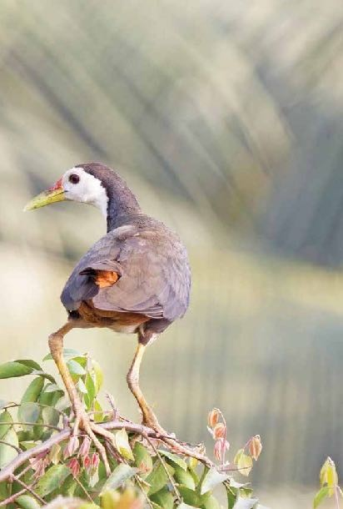

Least Concern (IUCN 3.1)

**Scientific classification** Kingdom: Animalia Phylum: Chordata

Class: Aves

Order: Gruiformes

Family: Rallidae

Genus: *Amaurornis*

Species: *A. phoenicurus*

# 8.Red Wattled Lapwing

The **red-wattled lapwing** (*Vanellus indicus*) is an Asian lapwing or large plover. Like other lapwings they are ground birds that are incapable of perching. Their characteristic loud alarm calls are indicators of human or animal movements and the sounds have been variously rendered as *did he do it* or *pity to do it* leading to the colloquial name of *did-he- do-it* bird. Usually seen in pairs

or small groups and usually not far from water they sometimes form large aggregations in the non-breeding season (winter). They nest in a ground scrape laying three to four camouflaged eggs. Adults near the nest fly around, diving at potential predators while calling noisily. The cryptically patterned chicks hatch and immediately follow their parents to feed, hiding by lying low on the ground or in the grass when threatened.

Red-wattled lapwings are large waders, about 35 cm (14 in) long. The wings and back are light brown with a purple to green sheen, but the head, a bib on the front and back of the neck are black. Males and females are similar in plumage but males have a 5% longer wing and tend to have a longer carpal spur. The length of the birds is 320–350 mm, wing of 208–247 mm with the nominate averaging 223 mm, Sri Lanka 217 mm. The Bill is 31–36 mm and tarsus of 70–83 mm. Tail length is 104–128 mm.

It usually keeps in pairs or trios in well-watered open country, ploughed fields, grazing land, and margins and dry beds of tanks and puddles. They are said to feed at night being especially active around the full moon. Is uncannily and ceaselessly vigilant, day or night, and is the first to detect intrusions and raise an alarm, and was therefore considered a nuisance by hunters.

Its striking appearance is supplemented by its noisy nature, with a loud and scolding *did-he-do-it* call, uttered both in the day and night.

Leucistic abnormal plumages have been noted.

The local names are mainly onomatopoeic in origin and include

*titeeri* (Hindi), *and balighora* (Assamese).

## Conservation status

Extinct Threatned

EX EW CR EN VU

Least Concern

NT LC

19

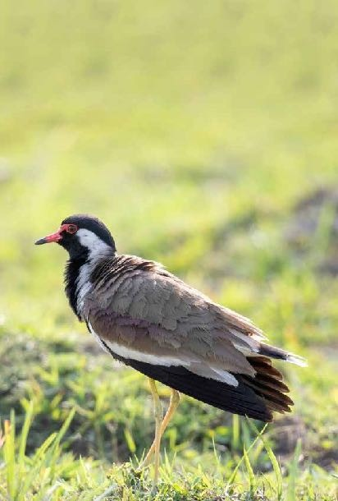

Least Concern (IUCN 3.1)

**Scientific classification** Kingdom: Animalia Phylum: Chordata

Class: Aves

Order: Charadriiformes

Family: Charadriidae Genus: *Vanellus* Species:

*V. indicus*

Photograph: Urjit Dwivedi

# 9. Yellow-footed Green Pigeon

The yellow-footed green pigeon (*Treron phoenicoptera*), also known as yellow-legged green pigeon, is a common species of green pigeon found in the Indian subcontinent. It is the state bird of Maharashtra. In Marathi it is called Hariyal. The species feeds on fruit, including many species of Ficus. They forage in flocks.

In the early morning they are often seen sunning on the tops of emergent trees in dense forest areas. They especially are found sitting in couples on tree branches.

Yellow-footed Green Pigeon feeds on fruits commonly and some edible seeds also. Large variety of the fruits are from *Ficus.*

## Conservation status

Extinct

EX EW

Threatned

CR EN VU

Least Concern

NT LC

23

Least Concern (IUCN 3.1)

**Scientific classification**

Kingdom: Animalia

Phylum: Chordata

Class: Aves

Order: Columbiformes

Family: Columbidae

Genus: Treron

Species: *T. phoenicoptera*

# 10. Spotted Dove

Thespotted dove *(Spilopeliachinensis)* is a small and somewhat long-tailed pigeonthatisacommonresidentbreedingbirdacross its native range on the Indian subcontinent and SoutheastAsia.

The species has been introduced into many parts of the world and feral populations have become established.

There are considerable plumage variations across populations within its wide range. The species is found in light forests and gardens as well as in

urban areas. They fly from the ground with an explosive flutter and will sometimes glide down to a perch. It is sometimes also called the mountain dove, pearl-necked dove or lace-necked dove.

Spotted doves move around in pairs or small groups as they forage on the ground for grass seeds, grains, fallen fruits and seeds of other plants. They may however take insects occasionally and have been recorded feeding on winged termites. The flight

is quick with regular beats and an occasional sharp flick of the wings.A display flight involves taking off at a steep angle with a loud clapping of the wing and then slowly gliding down with the tail spread out.

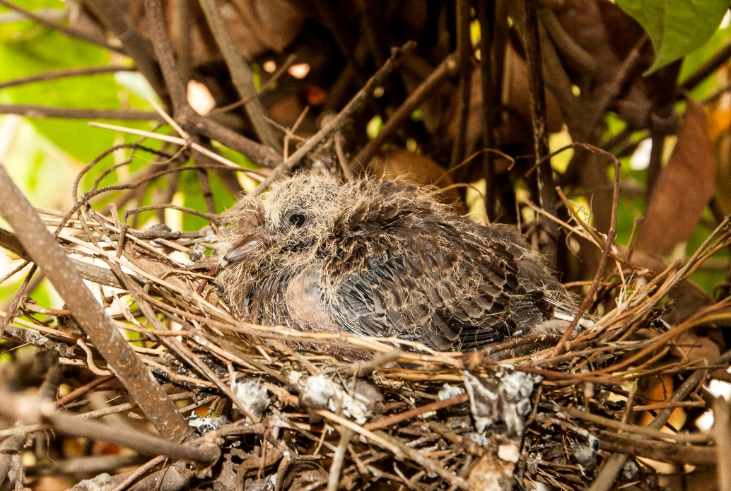

## Conservation status

Extinct Threatned

EX EW CR EN VU

Least Concern

NT LC

Least Concern (IUCN 3.1)

**Scientific classification** Kingdom: Animalia Phylum: Chordata

Class: Aves

Order: Columbiformes

Family: Columbidae

Genus: Spilopelia

Species: *S. chinensis*

# 11. Rose-ringed Parakeet

The rose-ringed parakeet(*Psittaculakrameri*),also known as the ring- necked parakeet, is a gregarious tropical Afro-Asian parakeet species that

has an extremely large range. 26

The rose-ringed parakeet is sexually dimorphic. The adult male sports a red or black neck ring and the hen and immature birds of both sexes either show no neck rings, or display shadow- like pale to dark grey neck rings. Both sexes have a distinctive green colour. It is herbivorous and not migratory.

One of the few parrot species that have successfully adapted to living in disturbed habitats, it has withstood the onslaught of urbanisation and deforestation. As a popular pet species, escaped birds have colonised a number of cities around the world, including Northern and Western Europe.

[2] Since the population appears to be increasing, the species was evaluated as being of least concern by the IUCN in 2012, but its popularity as a pet and unpopularity with farmers have both reduced its numbers in some parts of its native range.

In the wild, rose-ringed parakeets usually feed on buds, fruits, vegetables, nuts, berries, and seeds. In India, they feed on cereal grains, and during winter also on pigeon peas. In Egypt during the spring, they feed on mulberry and in summer they feed on dates and nest inside palm trees and eat from sunflower and corn fields.

Rose-ringed parakeets are popular as pets and they have a long history in aviculture. The ancient Greeks kept the Indian subspecies *P. kramerimanillensis*, and the ancient Romans kept the African subspecies *P. kramerikrameri.* Colour mutations of the Indian rose- ringed parakeet subspecies have become widely available in recent years.

Both males and females have the ability to mimic human speech. First, the bird listens to its surroundings, and then it copies the voice of the human speaker.

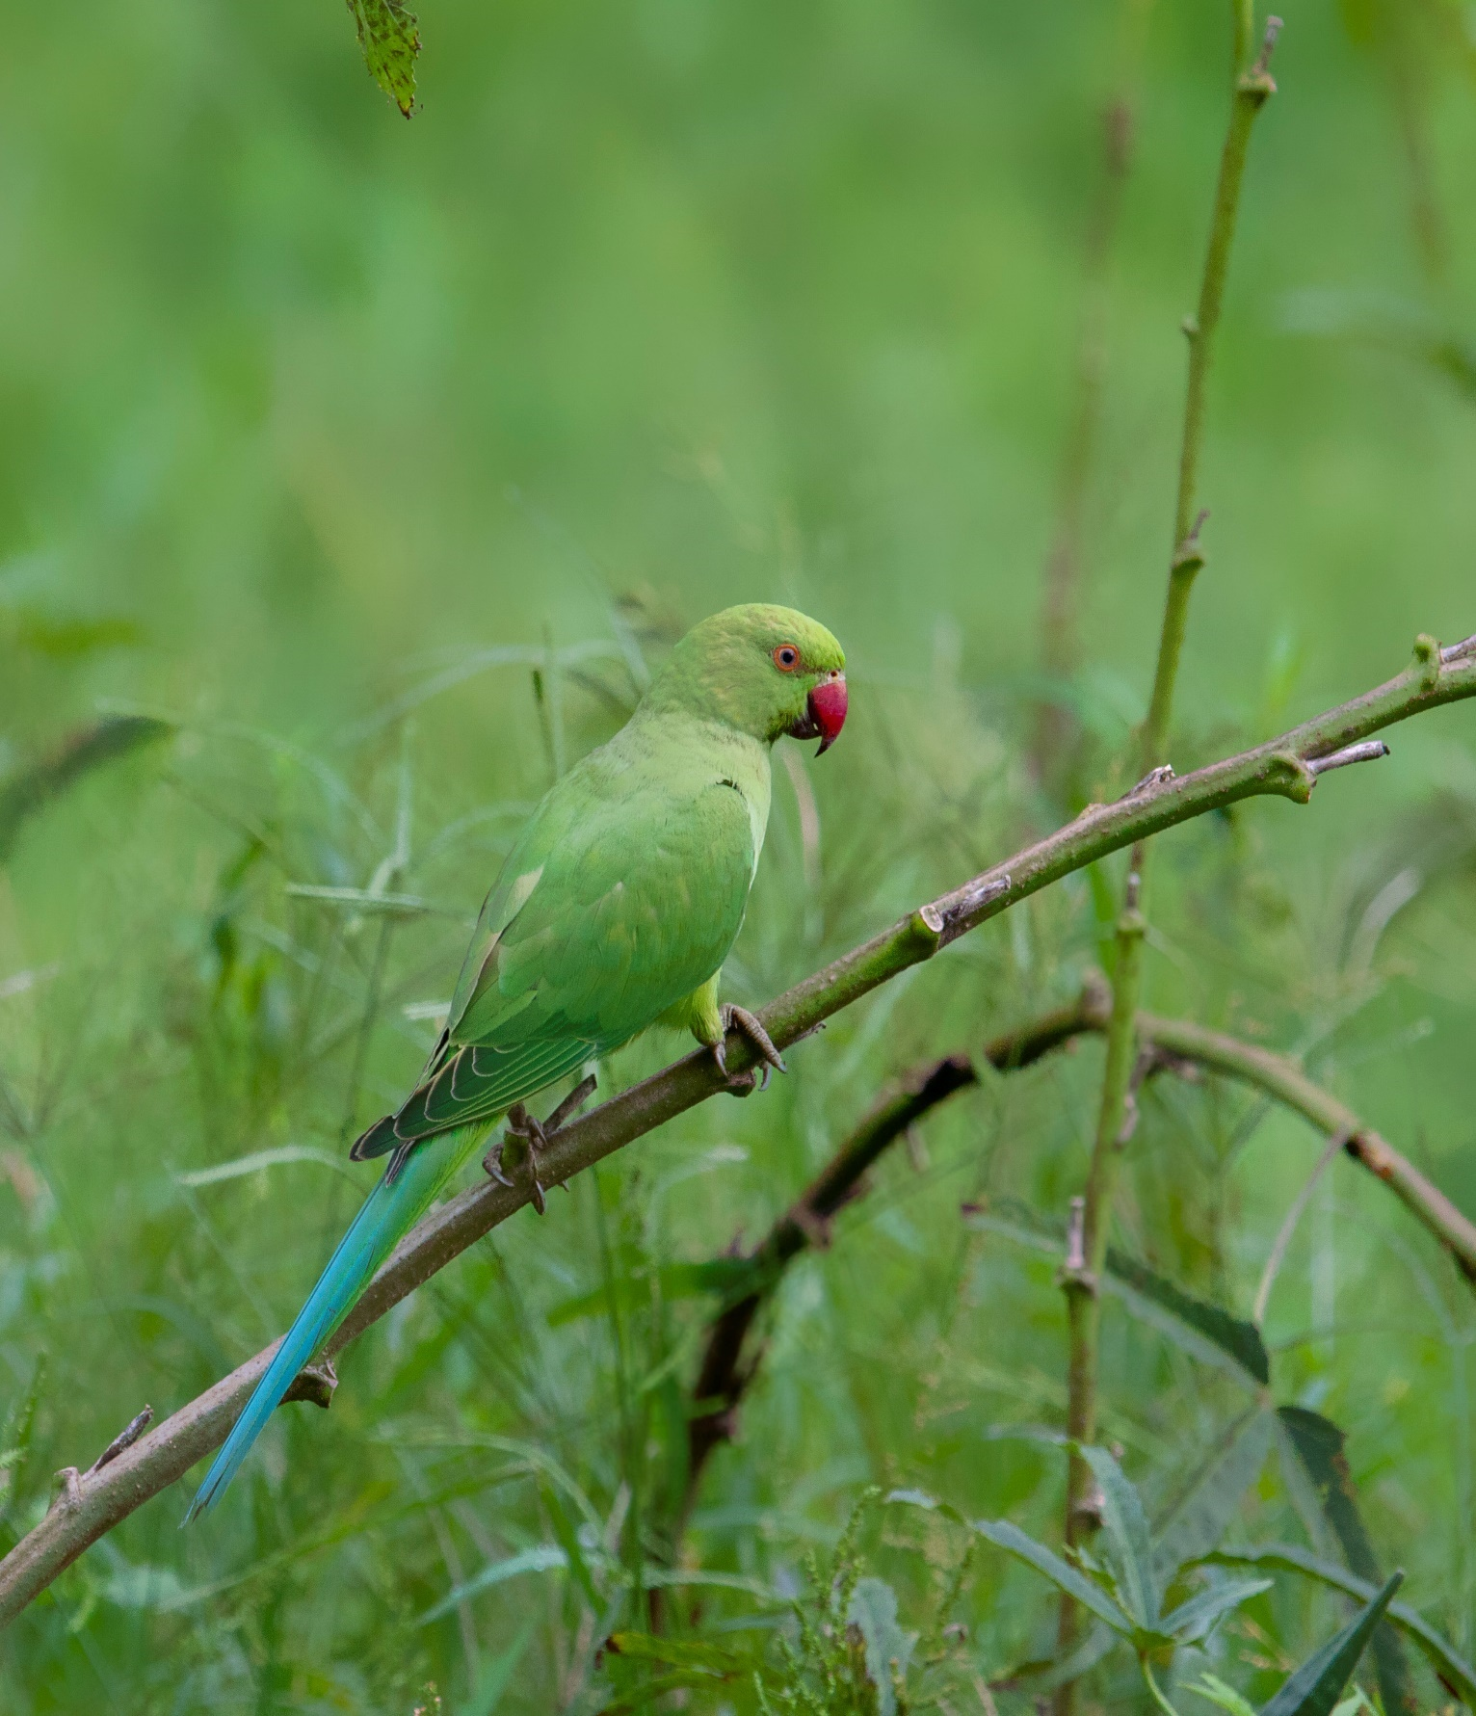

## Conservation status

Extinct Threatned

EX EW CR EN VU

Least Concern

NT

Least Concern (IUCN 3.1)

**Scientific classification**

Kingdom: Animalia

Phylum: Chordata

Class: Aves

Order: Psittaciformes

Family: Psittacidae

Genus: Psittacula

Species: *P. krameri*

Photograph: Urjit Dwivedi

# 12. Common Hawk-cuckoo

The common hawk-cuckoo (*Hierococcyx varius*), popularly known as the brainfever bird, is a medium-sized cuckoo resident in the Indian subcontinent. It bears a close resemblance to the Shikra, even in its style of flying and landing on a perch. The resemblance to hawks gives this group the generic name of hawk-cuckoo and like many other cuckoos these are brood parasites, laying their eggs in nests of babblers. During their breeding season in summer males produce loud, repetitive three note calls that are well- rendered as brain-fever, the second note being longer and higher pitched. These notes rise to a crescendo before ending abruptly and repeat after a few minutes; the calling may go on through the day, well after dusk and before dawn.

During summer months, before the monsoons, the males are easily detected by their repeated calls but can be difficult to spot. The call is a loud screaming three-note call, repeated 5 or 6 times, rising in crescendo and ending abruptly. It is heard throughout the day and frequently during moonlit nights.

The common hawk-cuckoo occurs in most of the Indian subcontinent, from Pakistan in the west, across the Himalayas foothills, east to Nepal, Bhutan and Bangladesh and south into Sri Lanka. Some birds of the Indian population winter in Sri Lanka. In the hills of central Sri Lanka, ciceliae is a resident. It is generally resident but where occurring at high altitudes and in arid areas is locally migratory. It is found in the lower elevations (mostly below 1000m) of the Himalayas but in the higher areas, the large hawk- cuckoo tends to be more common.

29

## Conservation status

Extinct Threatned

EX EW CR EN VU

Least Concern

NT LC

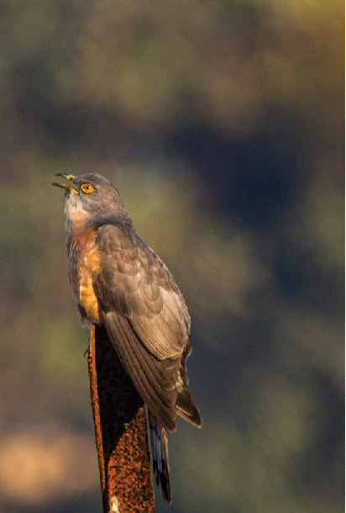

Least Concern (IUCN 3.1)

**Scientific classification** Kingdom: Animalia Phylum: Chordata

Class: Aves

Order: Cuculiformes

Family: Cuculidae

Genus: *Hierococcyx*

Species: *H. varius*

# 13. Eurasian Cuckoo

Th ecommon cuckoo (*Cuculuscanorus*) is a member of the cuckoo order of birds, *Cuculiformes*, which includes the roadrunners, the

anis and the coucals.

This species is a widespread summer migrant to Europe and Asia, and winters in Africa. It is a brood parasite, which means it lays eggs in the nests of other bird species, particularly of dunnocks, meadow pipits, and reed warblers.Although its eggs

are larger than those of its hosts, the eggs in each type of host nest resemble

the host’s eggs. The adult too is a mimic, in its case of the sparrowhawk; since that species is a predator, the mimicry gives the female time to lay her eggs without being seen to do so.

Although the common cuckoo’s global population appears to be declining, it is classified of being of Least Concern by the International Union for Conservation of Nature. It is estimated that the species numbers between 25 million and 100 million

individuals worldwide, with around 12.6 million to 25.8 million of those birds breeding in Europe.

Essentially a bird of open land, the common cuckoo is a widespread summer migrant to Europe and Asia, and winters in Africa. Birds arrive in Europe in April and leave in September.

Aristotle was aware of the old tale that cuckoos turned into hawks in winter. The tale was an explanation for their absence outside the summer season. Aristotle rejected the claim, observing in his History of Animals that cuckoos do not have the predators’talons or hooked bills. The 13th century medieval English round, “Sumer Is Icumen In”, celebrates the cuckoo as a

sign of spring, the beginning of summer, in the first stanza, and in the chorus.

In England,William Shakespeare alludes to the common cuckoo’s association withspring.

## Conservation status

Extinct Threatned

EX EW CR EN VU

Least Concern

NT LC

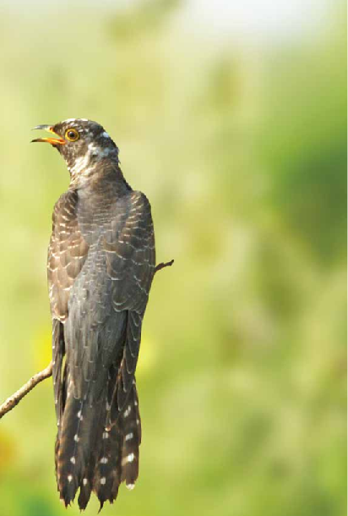

Least Concern (IUCN 3.1)

**Scientific classification** Kingdom: Animalia Phylum: Chordata

Class: Aves

Order: Cuculiformes

Family: Cuculidae

Genus: *Cuculus*

Species: *C. canorus*

# 14. Asian Koel

The Asian koel (*Eudynamys scolopaceus*) is a member of the cuckoo order of birds, the Cuculiformes. It is found in theIndian Subcontinent, China, and Southeast Asia. It forms a superspecies with the closely related black-billed and Pacific koels which

34

are sometimes treated as subspecies. The Asian koel is a brood parasite that lays its eggs in the nests of crows and other hosts, who raise its young. They are unusual among the cuckoos in being largely frugivorous as adults. The namekoel is echoic in origin with several language variants.The bird is a widely used symbol in Indianpoetry.

The Asian koel is a bird of light woodland and cultivation. It is a mainly resident breeder in tropical southern Asia from India, Bangladesh and Sri Lanka to southern China and the Greater Sundas.

Some populations may make long distance movements.

The Asian koel is a brood parasite, and lays its single egg in the nests of a variety of birds, including the jungle crow and house crow. In Sri Lanka before 1880 it was only known to parasitize the jungle crow, later shifting to the house crow.

TheAsian koel is omnivorous, consuming a variety of insects, caterpillars, eggs and small vertebrates. Adults feed mainly on fruit. They will sometimes defend fruiting trees that they forage in and chase away other frugivores. They have been noted to

be especially important in the dispersal of the sandalwood tree

(*Santalum album*) in India. Large seeded fruits are sometimes quickly regurgitated near the parent tree while small seeded fruits are ingested and are likely to be deposited at greater distances from the parenttree.

These birds were once very popular in India as cagebirds.

Feeding even on boiled rice, these hardy birds lived in captivity for as long as 14 years.

## Conservation status

Extinct Threatned

EX EW CR EN VU

Least Concern

NT LC

35

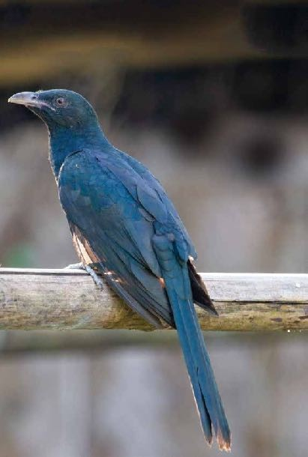

Least Concern (IUCN 3.1)

**Scientific classification** Kingdom: Animalia Phylum: Chordata

Class: Aves

Order: Cuculiformes

Family: Cuculidae

Genus: *Eudynamys*

Species: *E. scolopaceus*

Photograph: Urjit Dwivedi

# 15. Greater Coucal

56

The greater coucal or crow pheasant (*Centropus sinensis*), is a large non-parasitic member of the cuckoo order of birds, the Cuculiformes. A widespread resident in the Indian Subcontinent and Southeast Asia, it is divided into several subspecies, some being treated as full species. They are large, crow-like with a long tail and coppery brown wings and found in wide range of habitats from jungle to cultivation and urban gardens. They are weak fliers, and are often seen clambering about in vegetation or walking on the ground as they forage for insects, eggs and nestlings of other birds. They have a familiar deep resonant call which is associated with omens in many parts of its range.

This is a large species of cuckoo at 48 cm. The head is black, upper mantle and underside are black glossed with purple. The back and wings are chestnut brown. There are no pale shaft streaks on the coverts. The eyes are ruby red. Juveniles are duller black with spots on the crown and there are whitish bars on the underside and tail.

The nominate race is found from the Indus Valley through the sub-

Himalayan and Gangetic plains to Nepal, Assam and the Bhutan foothills into southern China

## Conservation status

Extinct

EX EW

Threatned

CR EN VU

Least Concern

NT LC

Least Concern (IUCN 3.1) **Scientific classification** Kingdom: Animalia

Phylum: Chordata

Class: Aves

Order: Cuculiformes

Family: Cuculidae

Genus: Centropus

Species: *C. sinensis*

37

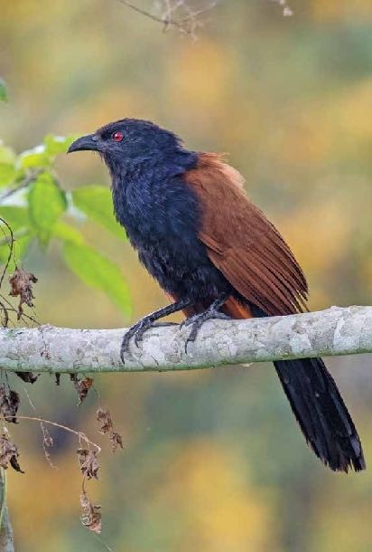

Photograph: Urjit Dwivedi

# 16. Spotted Owlet

The spotted owlet (*Athene brama*) is a small owl which breeds in tropical Asia from mainland India to Southeast Asia. A common resident of open habitats including farmland and human habitation, it has adapted to living in cities. They roost in small groups in the hollows of trees or in cavities in rocks or buildings. It nests in a hole in a tree or building, laying 3–5 eggs.

They are often found near human habitation. The species shows great variation including clinal variation in size and forms a superspecies with the very similar little owl.

These birds, being very familiar to humans especially with their loud calling, have been associated with bad omens. The speciesname*brama*is fromtheFrenchname*Chouettebrame*and indirectly refers to this owl's Indian habitat by way of homage to Brahma, the Hindu supreme spirit. In Hindu mythology the owl is a vahan (mode of transport) of Lakshmi, goddess of wealth.

## Conservation status

Extinct

EX EW

Threatned

CR EN VU

Least Concern

NT LC

Least Concern (IUCN 3.1)

**Scientific classification**

Kingdom: Animalia

Phylum: Chordata

Class: Aves

Order: Strigiformes

Family: Strigidae

Genus: Athene

Species: *A. brama*

39

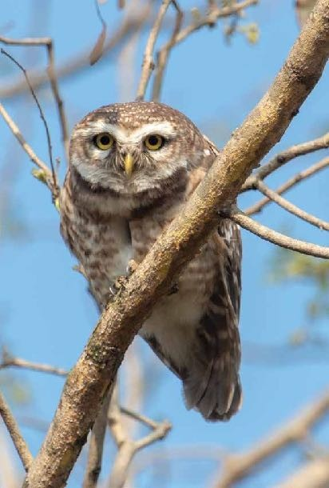

Photograph: Urjit Dwivedi

# 17.Asian Barred Owl

The Asian barred owlet(*Glaucidiumcuculoides)*is a species of true owl, resident in northern parts of the Indian Subcontinent and parts of Southeast Asia. It ranges across north central and northeast India, Nepal Bhutan, north Bangladesh, and southeast Asia (Myanmar,Thailand, Cambodia, Laos,Vietnam). Its natural habitat is temperate forest.

## Conservation status

Extinct Threatned

EX EW CR EN VU

Least Concern

NT LC

Least Concern (IUCN 3.1)

**Scientific classification** Kingdom: Animalia Phylum: Chordata

Class: Aves

Order: Strigiformes

Family: Strigidae

Genus: *Glaucidium*

Species: *G. cuculoides*

43

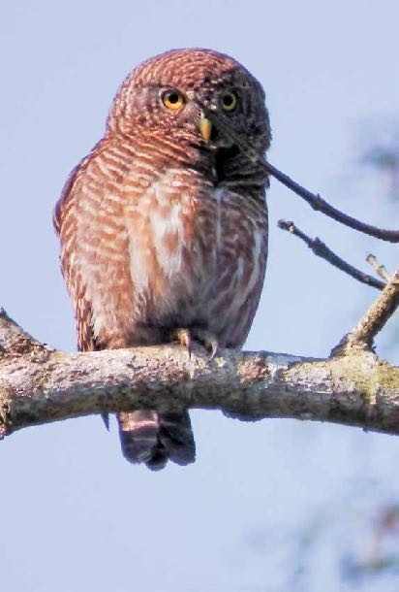

Photograph: Urjit Dwivedi

# 18. Brown Hawk Owl

The brown hawk-owl (*Ninoxscutulata*), also known as the brown boobook, is an owl which is a resident breeder in south Asia from India, Sri Lanka, Bangladesh and Nepal east to western Indonesia and south China.

This species is a part of the larger grouping of owls known as typical owls, Strigidae, which contains most species of owl. The other grouping is the barn owls, Tytonidae.

The brown hawk-owl is a resident breeder in most of tropical south Asia from the Middle East to south China. Its habitat is well- wooded country and forest. It lays three to five eggs in a tree hole.

The brown hawk-owl is a medium-sized (32 cm) owl with a hawk- like shape due to its long tail and lack of a distinct facial disk. The upperparts are dark brown, with a barred tail. The underparts are whitish with reddish-brown streaking, although the subspecies found in the Andaman Islands has dark brown underparts. The tail is barred. The eyes are large and yellow. Sexes are similar.

This species is very nocturnal but it can often be located by the small birds that mob it while it is roosting in a tree. It feeds mainly on large insects, frogs, lizards, small birds, and mice. The call is a repeated lows oft, musical*oo-uk...ooo-uk...*which may be heard at dusk and dawn. This owl is quite common in towns and cities like Colombo, Sri Lanka as well as suburban areas close to buildings.

There is only one record of the brown hawk-owl in the western hemisphere, an individual photographed on St. Paul Island, Alaska, on August 27, 2007.

## Conservation status

Extinct Threatned

EX EW CR EN VU

Least Concern

NT LC

45

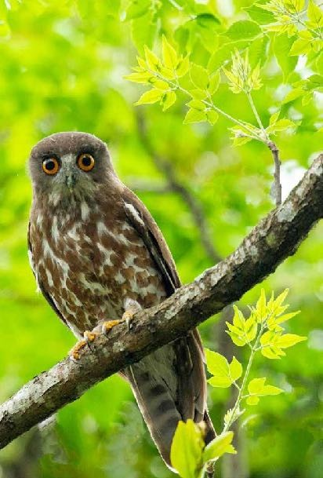

Least Concern (IUCN 3.1)

**Scientific classification** Kingdom: Animalia

Phylum: Chordata

Class: Aves

Order: Strigiformes

Family: Strigidae

Genus: Ninox

Species: *N. scutulata*

Photograph: Urjit Dwivedi

# 19. Little Swift (House Swift)

The little swift (*Apus affinis*), is a small species of swift found in Asia and Africa. It is found both in urban areas and rocky cliffs where it builds its nest in the many typical of all members of the order Apodiformes. A former eastern population is now separated in a distinct species, house swift (Apus nipalensis).

These birds have very short legs which they use only for clinging to vertical surfaces. The genus name Apus is Latin for a swift, thought by the ancients to be a type of swallow with no feet The Latin specific affinis means similar to or related to, but in this case the species that the little swift supposedly resembles is not clear from the description. They never settle voluntarily on the ground.

Little swifts breed around habitation and cliffs from southern Spain, Africa northeastwards through southern Pakistan and India and Sri Lanka. Unlike the more northerly common swift, many birds are resident, but some populations are migratory.

Little swifts build their nests in hole in buildings or sometimes on cliffs,

laying 1–4 eggs.Aswift will return to the same site year after year, rebuilding its nest when necessary.

Little swifts spend most of their lives in the air, living on the insects they catch in their beaks. They drink on the wing, but roost on vertical cliffs or walls. Little swifts are readily identified by their small size. Their wingspan is 33 cm compared to the 42 cm of common swift. They are black except for a white rump, the white extending on to the flanks. They have a short square tail. The flight is fluttering like a house martin.The call is a high twittering.

## Conservation status

Extinct Threatned

EX EW CR EN VU

Least Concern

NT LC

Least Concern (IUCN 3.1)

47

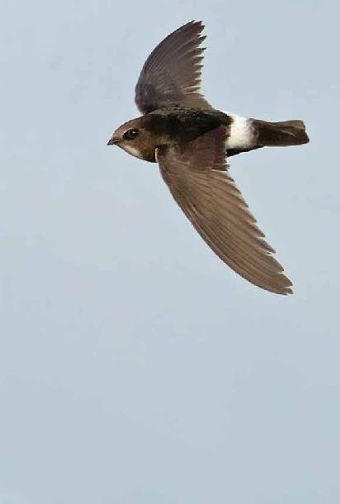

**Scientific classification** Kingdom: Animalia Phylum: Chordata

Class: Aves

Order: Apodiformes

Family: Apodidae

Genus: *Apus*

Species: *A. affinis*

Photo source Internet

# 20. Indian Roller

56

The Indianroller (*Coraciasbenghalensis*), is a member of the roller family of birds.They are found widely across tropical Asia from Iraq eastward across the Indian Subcontinent to Indochina and are best known for the aerobatic displays of the male during the breeding season. It is not migratory, but undertakes some seasonal movements. The largest populations of the species are within India, and several states in India have chosen it as their state bird.

48

The Indian roller is a stocky bird about 26–27 cm long and can only be confused within its range with the migratory European roller. The breast is brownish and not blue as in the European Roller. The crown and vent are blue. The primaries are deep purplish blue with a band of pale blue. The tail is sky blue with a terminal band of Prussian blue and the central feathers are dull green. The neck and throat are purplish lilac with white shaft streaks. The bare patch around the eye is ochre in colour.

Indian rollers are often seen perched on prominent bare trees or wires. They descend to the ground to capture their prey which may include insects, arachnids, small reptiles, small snakes and amphibians. In agricultural habitats in southern India, they have been found at densities of about 50 birds per km2. They perch mainly on 3—10 metre high perches and feed mostly on ground insects. Nearly 50% of their prey are beetles and 25% made up by grasshoppers and crickets.

The Indian roller is very common in the populated plains of India and associated with Hindu legends. It is said to be sacred to Vishnu, and used to be caught and released during festivals such as Dussera or the last day of Durga Puja. A local Hindi name is neelkanth, meaning “blue throat”, a name associated with

the deity Shiva (who drank poison resulting in the blue throat). Adding its chopped feathers to grass and feeding them to cows was believed to increase their milk yield. The Indian roller has been chosen as the state bird by the Indian states of Andhra Pradesh, Odisha, Karnataka and Telangana.

## Conservation status

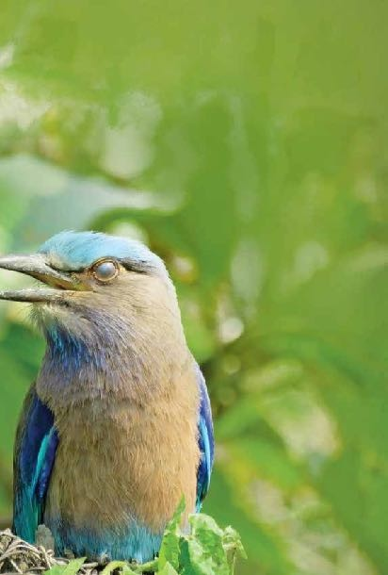

Extinct Threatned

EX EW CR EN VU

Least Concern

NT LC

49

Least Concern (IUCN 3.1)

**Scientific classification**

Kingdom: Animalia

Phylum: Chordata

Class: Aves

Order: Coraciiformes

Family: Coraciidae

Genus: *Coracias*

Species: *C. benghalensis*

# 21.White Throated Kingfisher

The white-throated kingfisher (*Halcyon smyrnensis*) also known as the white-breasted kingfisher is a tree kingfisher, widely distributed in Asia from Turkey east through the Indian

subcontinent to the Philippines. This kingfisher is a resident over much of its range, although some populations may make short distance movements. It can often be found well away from water where it feeds on a wide range of prey that includes small reptiles, amphibians, crabs, small rodents and even birds. During the breeding season they call loudly in the mornings from prominent perches including the tops of buildings in urban areas or on wires.

Birds have sometimes been seen attracted to lights at night, especially during the monsoon season, suggesting that they are partly migratory.

## Conservation status

Extinct Threatned

EX EW CR EN VU

Least Concern

NT LC

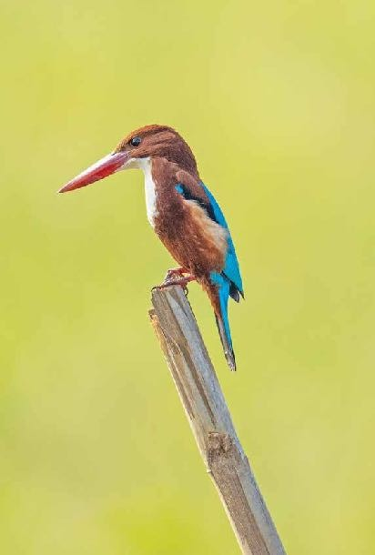

Least Concern (IUCN 3.1)

**Scientific classification** Kingdom: Animalia

Phylum: Chordata

Class: Aves

Order: Coraciiformes

53

# 22. Common KingFisher

The common kingfisher (*Alcedo atthis*) also known as the Eurasian kingfisher, and river kingfisher, is a small kingfisher with seven subspecies recognized within its wide distribution across Eurasia and North Africa. It is resident in much of its range, but migrates from areas where rivers freeze in winter.

54

This sparrow-sized bird has the typical short-tailed, large- headed kingfisher profile; it has blue upperparts, orange underparts and a long bill. It feeds mainly on fish, caught by diving, and has special visual adaptations to enable it to see prey under water. The glossy white eggs are laid in a nest at the end of a burrow in a riverbank.

Common kingfishers are important members of ecosystems and good indicators of freshwater community health. The highest densities of breeding birds are found in habitats with clear water, which permits optimal prey visibility, and trees or shrubs on

the banks. These habitats have also the highest quality of water, so the presence of this bird confirms the standard of the water.

[12] Measures to improve water flow can disrupt this habitat, and in particular, the replacement of natural banks by artificial confinement greatly reduces the populations of fish, amphibians and aquatic reptiles, and waterside birds are lost.[13] It can tolerate a certain degree of urbanisation, provided the water remains clean.

This species is resident in areas where the climate is mild year- round, but must migrate after breeding from regions with

prolonged freezing conditions in winter. Most birds winter within the southern parts of the breeding range, but smaller numbers cross the Mediterranean into Africa or travel over the mountains of Malaysiainto Southeast Asia. Kingfishers migrate mainly at night, and some Siberian breeders must travel at least 3,000 km (1,900 mi) between the breeding sites and the wintering areas.

## Conservation status

Extinct Threatned

### EX EW CR EN VU

Least Concern

### NT LC

55

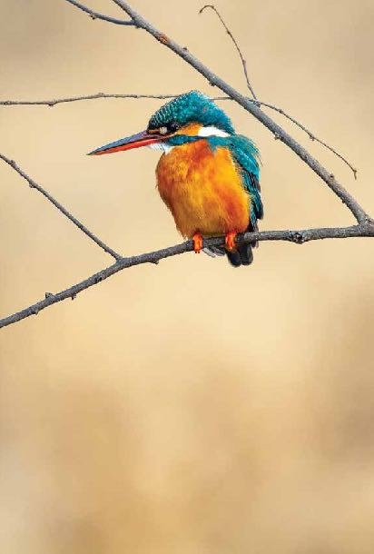

Least Concern (IUCN 3.1)

**Scientific classification**

Kingdom: Animalia

Phylum: Chordata

Class: Aves

Order: Coraciiformes

Family: Alcedinidae

Genus: *Alcedo*

Species: *A. atthis* Photograph: Urjit Dwivedi

# 23. Blue-tailed Bee-eater

Theblue-tailed bee-eater(*Meropsphilippinus*)is an ear passerine bird in the bee-eater family Meropidae. It breeds in southeastern Asia. It is strongly migratory, seen seasonally in much of peninsular India.

This species is sometimes considered to be conspecific with the blue- cheeked bee-eater, M. persicus.

This species, like other bee-eaters, is a richly coloured, slender bird. It is

predominantly green; its face has a narrow blue patch with a black eye stripe, and a yellow and brown throat; the tail

is blue and the beak is black. It can reach a length of 23–26 cm, including the two elongated central tail feathers. Sexes are alike.

This is a bird which breeds in sub-tropical open country, such as

farmland, parks or ricefields. It is most often seen near large waterbodies. Like other bee-eaters it predominantly eats insects, especially bees, wasps and hornets, which are caught in the air by sorties from an open perch.This species probably takes bees and dragonflies in roughly equal numbers. The insects that are caught are beaten on the perch to kill and break the exoskeleton. This habit is seen in many other members of the coracii formes order.

These bee-eaters are gregarious, nesting colonially in sandy banks or open flat areas. They make a relatively long tunnel in which the 5 to 7 spherical white eggs are laid. Both the male and the female take care of the eggs. These birds also feed and roost communally. The call is similar to that of the European bee-eater.

## Conservation status

Extinct Threatned

### EX EW CR EN VU

Least Concern

### NT LC

Least Concern (IUCN 3.1)

57

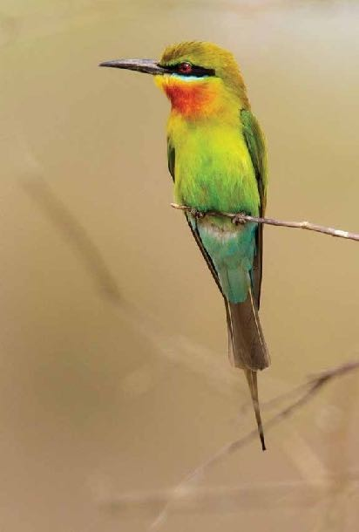

**Scientific classification** Kingdom: Animalia

Phylum: Chordata

Class: Aves

Order: Coraciiformes

Family: Meropidae

Genus: *Merops*

Species: *M. philippinus*

Photograph: Urjit Dwivedi

# 24. Eurasian Hoopoe

The Eurasian hoopoe (*Upupa epops*) is the most widespread species of the genus Upupa, native to Europe, Asia and the northern half of Africa.

The Eurasian hoopoe is a medium-sized bird, 25–32 cm (9.8–12.6in) long, witha 44–48 cm (17–19 in)wingspan. It weighs 46–89 g (1.6–3.1 oz). The species is highly distinctive, witha long, thin tapering bill that is black with a fawn base. The strengthened musculature of the head allows the bill to be opened when probing inside the soil. The hoopoe has broad and rounded wings capable of strong flight; these are larger in the northern migratory subspecies. The hoopoe has a characteristic undulating flight, which is like that of a giant butterfly, caused by the wings half closing at the end of each beat or short sequence of beats. Adults may begin their moult after the breeding season and continue after they have migrated for the winter.

58

The call is typically a trisyllabic oop-oop-oop.

The Eurasian hoopoe is widespread in Europe, Asia, and North Africa and northern Sub-Saharan Africa. Most European and north Asian birds migrate to the tropics in winter.[5] In contrast, the African populations are sedentary all year. The species has been a vagrant in Alaska; U. e. saturata was recorded there in 1975 in theYukon Delta. Hoopoes have been known to breed north of their European range, and in southern England during warm, dry summers that provide plenty of grasshoppers and similar insects, although as of the early 1980s northern European populations were reported to be in the decline, possibly due to changes in climate.

The hoopoe has two basic requirements of its habitat: bare or lightly vegetated ground on which to forage and vertical surfaces with cavities (such as trees, cliffs or even walls, nestboxes, haystacks, and abandoned burrows) in which to nest. These requirements can be provided in a wide range of ecosystems, and as a consequence the hoopoe inhabits a wide range of habitats such as heathland, wooded steppes, savannas and grasslands, as well as forestglades.

## Conservation status

Extinct Threatned

EX EW CR EN VU

Least Concern

NT LC

Least Concern (IUCN 3.1)

59

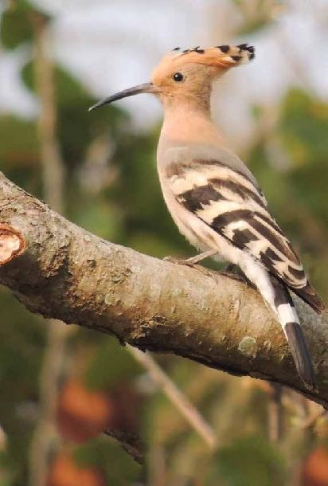

**Scientific classification** Kingdom: Animalia Phylum: Chordata

Class: Aves

Order: Bucerotiformes

Family: Upupidae

Genus: *Upupa*

Species: *U. epops*

Photograph: Urjit Dwivedi

25. Oriental Pied Hornbill

The oriental pied hornbill (*Anthracoceros albirostris*) is an Indo- Malayan pied hornbill, a large canopy-dwelling bird belonging to the Bucerotidae family. Two other common names for this species are sunda pied hornbill (convexus) and Malaysian pied hornbill. The species is considered to be among the smallest and most common of the Asian hornbills. It has the largest distribution

62

in the genus and is found in the Indian Subcontinent and throughout Southeast Asia. Its naturalhabitat is subtropical or tropical moist lowland forests.

The oriental pied hornbill is found in the Indian Subcontinent and Southeast Asia, ranging across Bangladesh,Bhutan, Brunei, Cambodia, Eastern and NorthernIndia, Indonesia, Laos, North peninsular Malaysia, Myanmar, Nepal, Singapore, Thailand, Tibet, Vietnam and the Sunda shelf islands. Its natural habitat is subtropical or tropical moist lowland forests.

Hornbills are predominantly frugivores.The oriental pied hornbill’s diet consists of wild fruits such as figs (Ficus spp.), melanoxylon berries, rambutans, palm fruit, papaya and fruits of liana plants.It will also take large insects (grasshoppers), small birds (finches) small reptiles (lizards and snakes), amphibians

such as frogs, and fish. Feeding on a diversity of fruits ensure that nutritional requirements are met. In the non-breeding season fruits that are selected for are generally sugar rich, while lipid- rich fruits and invertebrates are highly selected for during the breeding season.

Oriental pied hornbills are important large seed dispersers, promoting seedling recruitment by translocating the seeds of the fruits they feed on.

Hornbills select nest sites based on the availability and type of fruiting

trees, as well as on the availability and quality of nest site cavities in their particular habitat.Some oriental pied hornbills have demonstrated tree species preferences for nest site selection.

## Conservation status

Extinct Threatned

EX EW CR EN VU

Least Concern

NT LC

63

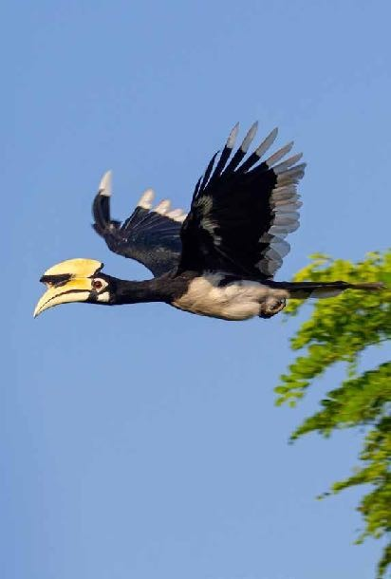

Least Concern (IUCN 3.1)

**Scientific classification** Kingdom: Animalia Phylum: Chordata

Class: Aves

Order: Bucerotiformes

Family: Bucerotidae

Genus: *Anthracoceros*

Species: *A. albirostris* Photograph: Urjit Dwivedi

# 26. Great Hornbill

The great hornbill is a large bird, 95–130 cm (37–51 in) long, with a 152 cm (60 in) wingspan and a weight of 2.15 (4.7–8.8 lb). It is the heaviest, but not the longest, Asian hornbill. Females are smaller than males and have bluish-white instead of red eyes, although the orbital skin is pinkish. Like other hornbills, they have prominent “eyelashes”.

64

The most prominent feature of the hornbill is the bright yellow and black casque on top of its massive bill. The casque appears

U-shaped when viewed from the front, and the top is concave, with two ridges along the sides that form points in the front, whence the Latin species *epithetbicornis*(two-horned).The back of the casque is reddish in females, while the underside of the front and back of the casque is black in males.

The casque is hollow and serves no known purpose, although it is believed to be the result of sexual selection.

Male hornbills have been known to indulge in aerial casque butting, with birds striking each other in flight.[3] The male spreads the preen gland secretion, which

is yellow, onto the primary feathers and bill to give them thebright yellowcolour.[4]The

commissure of the beak is black and has a serrated edge which becomes worn with age.

The wing beats are heavy and the sound produced by birds in flight can be heard from a distance. This sound has been

likened to the puffing of a steam locomotive starting up. The flight involves

stiff flaps followed by glides with the fingers splayed and upcurled. They sometimes fly at great height over forests.

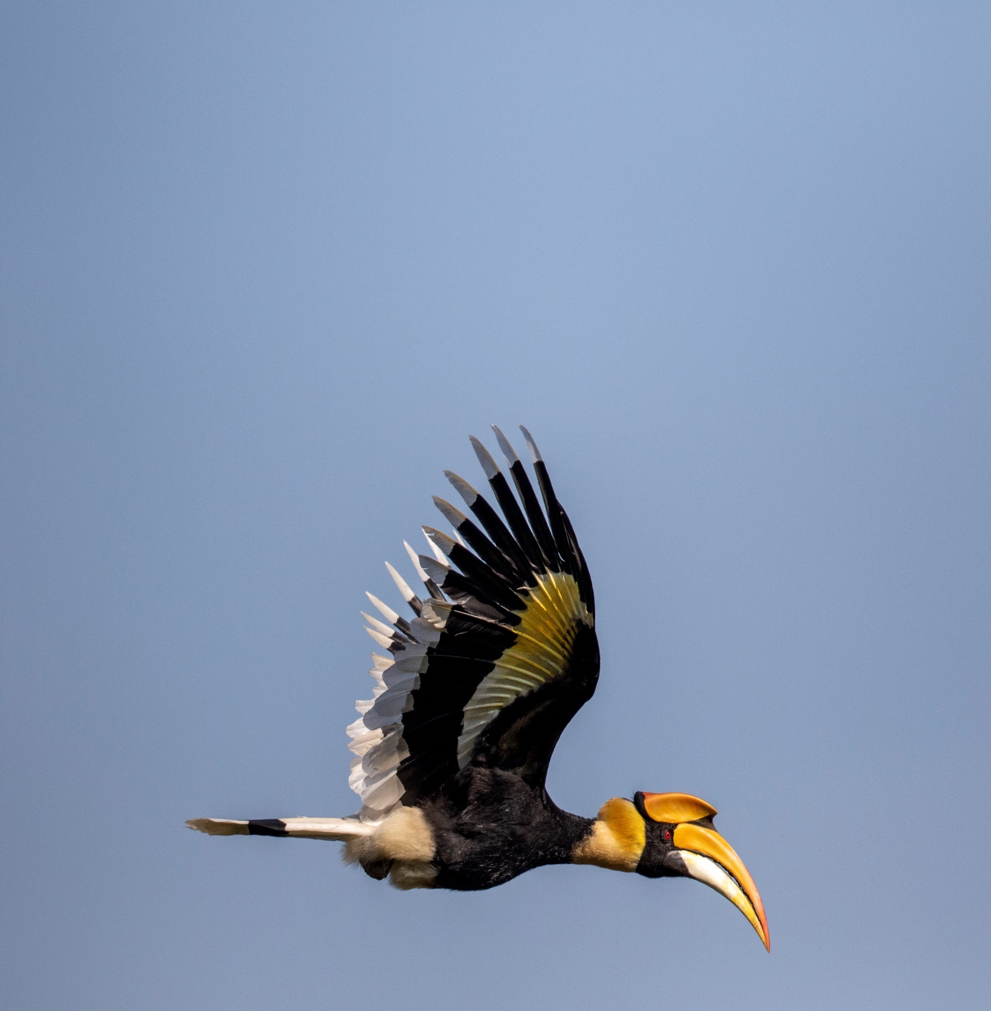

## Conservation status

Extinct Threatned

EX EW CR EN VU

Least Concern

NT LC

Vulnerable (IUCN 3.1)

**Scientific classification** Kingdom: Animalia

Phylum: Chordata

Class: Aves

Order: Bucerotiformes

Family: Bucerotidae

Genus: *Buceros*

Species: *B. bicornis*

# 27. Blue-throated Barbet

66

The blue-throated barbet (*Psilopogon asiaticus*) is an Asian barbet having bright green, blue & red plumage, seen across the Indian subcontinent and Southeast Asia. Barbets and toucans are a group of near passerine birds with a worldwide tropical distribution. The barbets get their name from the bristles which fringe their heavy bills; this species eats fruits and insects. They frequent evergreen forests, deciduous forests, gardens, orchards, teak forests and cities with fruiting trees. The turquoise- throated barbet was formerly considered a subspecies.

They are previously placed in the genus Megalaima and clumped as

*Megalaima asiatica* following Sibley and Monroe (1990,1993).

## Conservation status

Extinct Threatned

EX EW CR EN VU

Least Concern

NT LC

Least Concern (IUCN 3.1)

**Scientific classification** Kingdom: Animalia Phylum: Chordata

Class: Aves

Order: Piciformes

Family: Megalaimidae

Genus: *Psilopogon*

Species: *P.asiaticus*

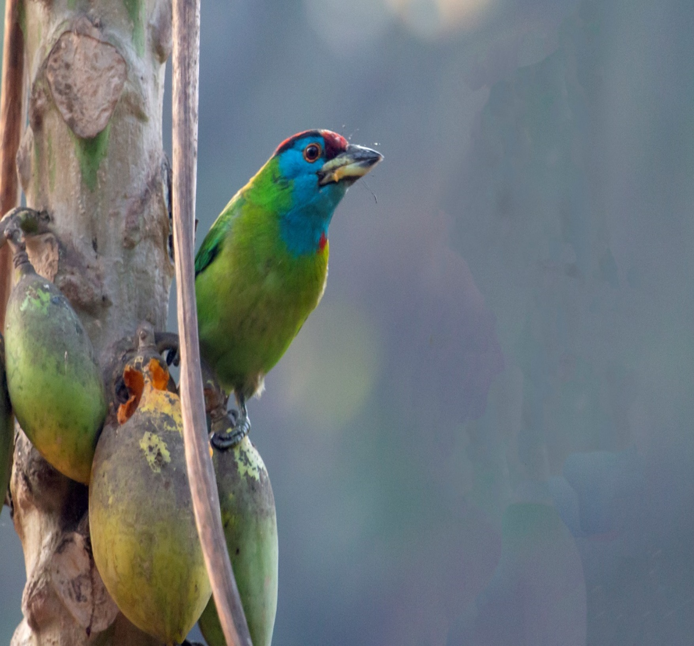

Photograph: Urjit Dwivedi

# 28. Coppersmith Barbet

The coppersmith barbet, crimson-breasted barbet or coppersmith (*Psilopogon haemacephalus*), is a bird with crimson forehead and throat which is best known for its metronomic

call that has been likened to a coppersmith striking metal with a hammer. It is a resident found in the Indian sub continent and

parts of Southeast Asia. Like other barbets, they chisel out a hole inside a tree to build their nest. They are mainly fruit eating but will take sometimes insects, especially winged termites.

Throughout their wide range they are found in gardens, groves and sparse woodland. Habitats with trees having dead wood suitable for excavation is said to be important. Birds nest and roost incavities.

Their call is a loud rather metallic tuk…tuk…tuk (or tunk), reminiscent of a copper sheet being beaten, giving the bird its name.

They prefer banyan, peepul, and other wild figs, various drupes and

berries, and the occasional insect, caught in aerial sallies.Petals of flowers may also be included in their diet.

They breed through much of the year with local variation. The breeding season is mainly February to April in India and December to September in Sri Lanka.

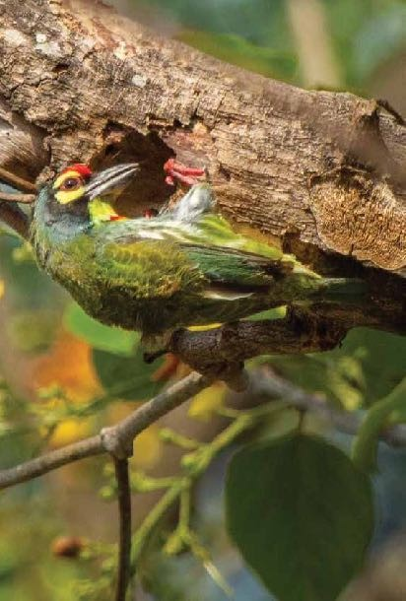

## Conservation status

Extinct Threatned

EX EW CR EN VU

Least Concern

NT LC

Least Concern (IUCN 3.1)

69

**Scientific classification** Kingdom: Animalia Phylum: Chordata

Class: Aves

Order: Piciformes Family: Megalaimidae Genus: *Psilopogon* Species:*P. haemacephalus*

Photograph: Urjit Dwivedi

29. Fulvous-breasted Woodpecker

Thefulvous-breastedwoodpecker (*Dendrocoposmacei*) is a species of bird in the family Picidae. It is found in Bangladesh, Bhutan, Nepal, India and Myanmar. The freckle-breasted woodpecker was formerly considered conspecific with this species.

Amedium-sized, pied woodpecker. Upperparts black, heavily barred white. Undertail red, breast and belly buff with light flank barring and slight side streaking.Withish cheeks partly bordered by black line. Crown red in male with orange forehead, black in female.

Its natural habitats are subtropical or tropical dry forest, subtropical or tropical moist lowland forest, and subtropical or tropical moist montane forest.

## Conservation status

Extinct

EX EW

Threatned

CR EN VU

Least Concern

NT LC

Least Concern (IUCN 3.1)

**Scientific classification**

Kingdom: Animalia

Phylum: Chordata

Class: Aves

Order: Piciformes

Family: Picidae

Genus: Dendrocopos

Species: *D. macei*

73

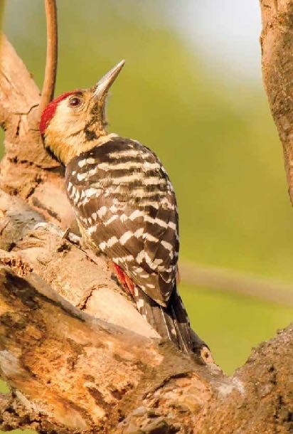

Photograph: Urjit Dwivedi

# 30. Himalayan Flameback

TheHimalayanflameback (*Dinopiumshorii*), also known as the Himalayan goldenback, is a species of bird in the family Picidae. At the moment very little is known of this species and more fieldwork is required. The Himalayan flameback is not threatened but it is suspected that deforestation could severely affect the species population.

The Himalayan flameback is very similar in appearance to the Greater Goldenback (*Chrysocolaptes lucidus*), but is not at all closely related.The primary difference is its smaller size and bill. The Himalayan flameback can be identified by: their black hind neck, the brownish centre on their throat, that can go down the breast on some and is bordered by an irregular black spotting.

They also have an indistinct divided moustachial stripe, the centre of

which is brownish and sometimes reddish in males. The Himalayan flameback also has ether reddish or brown eye and three toes. The breast of the Himalayan flameback is irregularly streaked with black but on occasion completely white. Their wings are coppery brown to red in colour. Lastly the males have

a yellowish-red forehead that becomes more red on the crest. In contrast, the female’s crest is entirely black streaked with white. In both sexes the crest is bordered by white and black bands on either side of their head.

Himalayan Flamebacks are commonly found in the Indian subcontinent, primarily in the lower-to-middle altitudes of the Himalayan sal forest region. Its range spans across Bangladesh, Bhutan, India, Myanmar, and Nepal, where they are year-round residents.

## Conservation status

Extinct Threatned

EX EW CR EN VU

Least Concern

NT LC

Least Concern (IUCN 3.1)

75

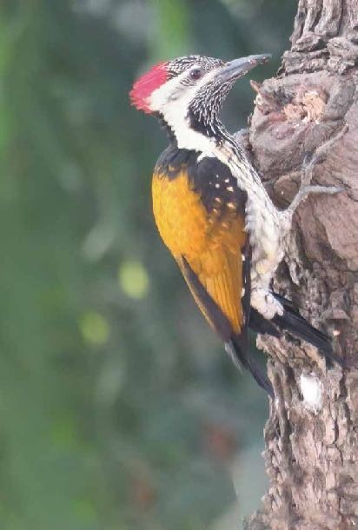

**Scientific classification** Kingdom: Animalia Phylum: Chordata

Class: Aves

Order: Piciformes

Family: Picidae

Genus: *Dinopium*

Species: *D. shorii*

Photograph: Urjit Dwivedi

# 31. Grey-backed Shrike

The grey-backed shrike *(Lanius tephronotus)* is a species of bird in the family Laniidae. It is found in Bangladesh, India (Uttarakhand), Nepal, Bhutan, China andYunnan.

Among the shrikes, they breed at the highest altitude. They are partial migrants, with some populations moving south in winter. They breed in summer from late May to early July.The nest is built in a bush and about 3 to 5 eggs are laid. The eggs are incubated

by the female alone and incubation is begun even before the complete clutch is laid. The chicks hatch after 15–18 days and are taken care of by both the parents until the fledge after about two weeks.

## Conservation status

Extinct Threatned

EX EW CR EN VU

Least Concern

NT LC

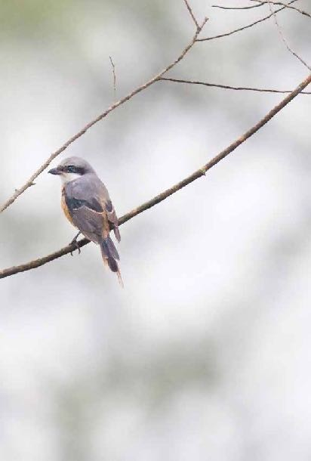

Least Concern (IUCN 3.1)

**Scientific classification**

32. White Wagtail

The white wagtail (*Motacilla alba*) is a small passerine bird in the wagtail family Motacillidae, which also includes the pipits and longclaws. This species breeds in much of Europe and Asia and parts of north Africa. It is resident in the mildest parts of its range, but otherwise migrates to Africa. It has a toehold in Alaska as a scarce breeder. In Ireland and Great Britain the darker sub- species the pied wagtail (*M. a. yarrellii)* predominates.

The white wagtail is an insectivorous bird of open country, often near habitation and water. It prefers bare areas for feeding, where it can see and pursue its prey. In urban areas it has adapted to foraging on paved areas such as car parks. It nests in crevices in stone-walls and similar natural and man-made structures.

The white wagtail is the national bird of Latvia.

White wagtail is resident in the milder parts of its range such as western Europe and the Mediterranean,

but migratory in much of the rest of its range. Northern European breeders winter around the

Mediterranean and in tropical and subtropical Africa, and Asiatic birds move

to the Middle East, India and Southeast Asia. Birds from the North

American population also winter in tropical Asia

## Conservation status Least

Extinct Threatned

EX EW CR EN VU

Concern

NT LC

79

Least Concern (IUCN 3.1)

**Scientific classification** Kingdom: Animalia Phylum: Chordata

Class: Aves

Order: Passeriformes

Family: Motacillidae

Genus: *Motacilla*

Species: *M. alba*

Photograph: Urjit Dwivedi

# 33. Paddyfield Pipit

The **paddyfield pipit** or **Oriental pipit** (*Anthus rufulus*) is a small passerine bird in the pipit and wagtail family. It is a resident

(non-migratory) breeder in open scrub, grassland and cultivation in southern Asia east to the Philippines. Although among the

few breeding pipits in the Asian region, identification becomes difficult in winter when several other species migrate into the region.

This is a large pipit at 15 cm, but is otherwise an undistinguished looking bird, mainly streaked grey-brown above and pale below with breast streaking. It is long legged with a long tail and a long dark bill. Sexes are similar. Summer and winter plumages are similar.Young birds are more richly coloured below than adults and have the pale edges to the feathers of the upper parts more conspicuous with more prominent spotting on the breast.

A widespread species found in open habitats, especially short

grassland and cultivation with open bare ground. It runs rapidly on the ground, and when flushed, does not fly far.

The paddyfield pipit breeds throughout the year but mainly in the dry season.

## Conservation status Least

Extinct Threatned

EX EW CR EN VU

Concern

NT LC

83

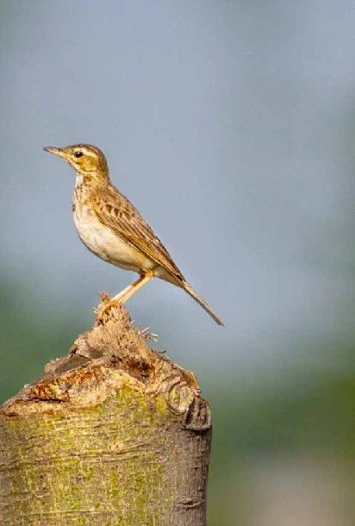

Least Concern (IUCN 3.1)

**Scientific classification** Kingdom: Animalia Phylum: Chordata

Class: Aves

Order: Passeriformes

Family: Motacillidae

Genus: *Anthus*

Species: *A. rufulus*

# 34. Cinereous Tit

The **cinereous tit** (*Parus cinereus*) is a species of bird in the tit family Paridae. This species is made up of several

populations that were earlier treated as subspecies of the great tit (*Parus major*). These birds are grey backed with white undersides. The great tit in the new sense is distinguishable by the greenish-back and yellowish underside. The distribution of

this species extends from parts ofWestAsia across South Asia and into SoutheastAsia.

Like others in the genus, it has a broad black ventral line and has no crest. This tit is part of a confusing group of species but is distinct in having a grey-back, black hood, white cheek patch and a white wing-bar. The underparts are white with the black central stripe running along the length. The female has a narrower ventral line and is slightly duller.[5] The upper tail coverts are ashy while the tail is black with the central 4 pairs of feathers ashy on the outer webs and all but the central pair are tipped white. The fifth pair is white with a black rachis and a band of black on the inner web. The outermost pair of tail feathers are all white with a black shaft. The undertail coverts are black towards the centre but white on thesides.

The calls are a whistling *titiweesi...titiweesi... witsi-seesee* or other variants repeated three of four times followed by a break. The calling is particularly persistent during the breeding season. In playback experiments, the *churring*alarm calls of the European *Parus major* and Asian species are responded to by each other but the songs of the European species do not elicit much response in *P.c. mahrattarum*. About 4 to 6 eggs form

the normal. The breeding season is summer and but dates vary across their range. Some birds may raise more than one brood. In southern India and Sri Lanka the breeding season is February to May (mainly before the Monsoons) but nests have also been seen from September to November.

The nests are placed in hollows

in trees or in a wall or mud-bank with a narrow entrance hole and the floor of the cavity is lined with moss, hair and feathers. They sometimes make use of the old nest of a woodpecker or barbet. Both parents take part in incubation and hissing from within the nest when threatened.They may also roost in cavities such as those in cut bamboo.

## Conservation status

Extinct Threatned

EX EW CR EN VU

Least Concern

NT LC

Least Concern (IUCN 3.1)

85

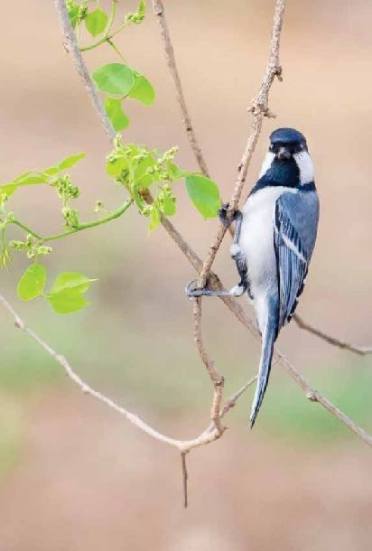

**Scientific classification** Kingdom: Animalia Phylum: Chordata

Class: Aves

Order: Passeriformes

Family: Paridae

Genus: *Parus*

Species: *P.major*

# 35. Jungle Babbler

The jungle babbler (*Turdoides striata*) is a member of the family Leiothrichidae found in the Indian subcontinent. They are gregarious birds that forage in small groups of six to ten birds, a habit that has given them the popular name of “Seven Sisters” in urban Northern India, and *Saathbhai* (seven brothers) in Bengali with cognates in other regional languages which also mean “seven brothers”.

The jungle babbler is a common resident breeding bird in most parts of the Indian subcontinent and is often seen in

gardens within large cities as well as in forested areas. In the past, the orange- billedbabbler,*Turdoidesrufescens*,ofSri Lanka was considered to be a subspecies of jungle babbler, but has now been elevated to a species.

The jungle babbler’s habitat is forest and cultivation. This species, like most babblers, is non-migratory, and has short rounded wings and a weak flight. The jungle babbler lives in flocks of seven to ten or more. It is a noisy bird, and the presence of a flock may generally be known at some distance by the harsh mewing calls, continual chattering, squeaking and chirping produced by its members.

## Conservation status

Extinct Threatned

EX EW CR EN VU

Least Concern

NT LC

87

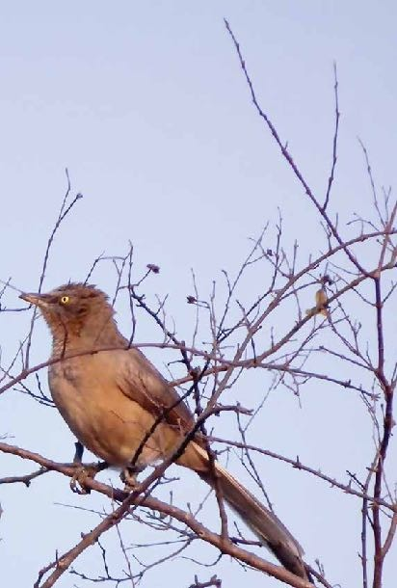

Least Concern (IUCN 3.1)

**Scientific classification** Kingdom: Animalia Phylum: Chordata

Class: Aves

Order: Passeriformes

Family: Leiothrichidae

Genus: *Turdoides*

Species: *T. striata*

Photograph: Urjit Dwivedi

# 36. Common Tailorbird

Tailorbirds (*Orthotomus sutorius*) are small birds, most belonging to the genus *Orthotomus*, often placed in the Old World warbler family Sylviidae. However, recent research suggests they more likely belong in the Cisticolidae and they are treated as such in Del Hoyo et al.These are rare species. One species, the mountain tailorbird (and therefore also its sister species rufous-headed tailorbird), is actually closer to an old world warbler genus Cettia

They occur in the Old World tropics, principally in Asia.

These warblers are usually brightly colored, with green or grey upper parts and yellow white or grey under parts. They often have chest nut on the head.

Tailorbirds have short rounded wings, short tails, strong legs and long curved bills. The tail is typically held upright, like a wren. They are typically found in open woodland, scrub and gardens.

Tailorbirds get their name from the way their nest is constructed. The edges of a large leaf are pierced and sewn together with plant fibre or spider’s web to make a cradle in which the actual grass nest is built.

## Conservation status

Extinct Threatned

EX EW CR EN VU

Least Concern

NT LC

89

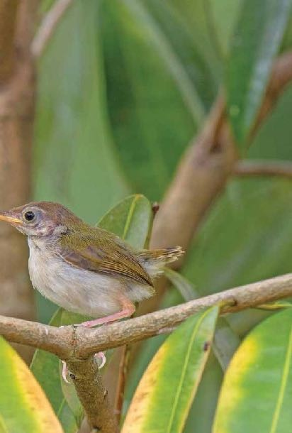

Least Concern (IUCN 3.1)

**Scientific classification** Kingdom: Animalia

Phylum: Chordata

Class: Aves

Order: Passeriformes

Family: Cisticolidae

Genus: *Orthotomus*

Species: *O. sutorius*

# 37. Greenish warbler

The greenish warbler (*Phylloscopus trochiloides*) is a widespread leaf warbler with a breeding range in northeastern Europe and temperate to subtropical continental Asia. This warbler is strongly migratory and winters in India.

Like all leaf warblers, it was formerly placed in the “OldWorld warbler” assemblage, but now belongs to the new leaf-warbler family Phylloscopidae.

This is a typical leaf warbler in appearance, grayish-green above and off-white below. The single wing bar found in the southern and western populations distinguishes them from most similar species (except Arctic warbler P. borealis). It is slightly smaller than that species and has a thinner bill, without a dark tip to the lower mandible. It breeds in lowland deciduous or mixed forest; non-breeding birds in the warmer parts of its range may move to montane habitat in summer. The nest is on the ground in low shrub.

## Conservation status

Extinct Threatned

EX EW CR EN VU

Least Concern

NT LC

Least Concern (IUCN 3.1)

**Scientific classification**

Kingdom: Animalia

Phylum: Chordata

Class: Aves

Order: Passeriformes

Family: Phylloscopidae

Genus: *Phylloscopus*

Species: *P.trochiloides*

93

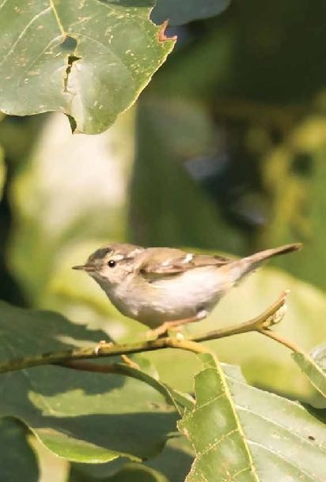

Photograph: Urjit Dwivedi

# 38. Grey-headed Canary flycatcher

The grey-headed canary-flycatcher sometimes known as the grey- headed flycatcher (*Culicicapa ceylonensis*) is a species of small flycatcher-like birdfound in tropical Asia. It has a square crest, a grey hood and yellow underparts. They are found mainly in forested habitats where they often join other birds in mixed- species foraging flocks.

Pairs are often seen as they forage for insects by making flycatcher-like sallies and calling aloud.

The grey-headed canary-flycatcher is about 12–13 cm long with a squarish grey head, a canary yellow belly and yellowish- green upperparts.[2] They forage actively like flycatchers and perches in a very upright posture. Across their range, populations differ in the shades of the colours and vary slightly in dimensions and several of these have been designated as subspecies.

This species breeds in upland to montane oak (*Quercus*) and other broadleaved forests and similar wooded areas in

temperate to tropical southern Asia, from Pakistan, Central India, Bangladesh and Sri Lanka east to Indonesia and southern China. Many populations are resident, but some Himalayan birds are partial migrants that winter in peninsular India sometimes even occurring in arid habitats. During the non-breeding season,

they are seen in the plains and lower elevations (September to March in India) when they prefer well wooded areas of relatively mature secondary forests, abandoned plantations and overgrown gardens, usually near water and streams including wooded gorges. They are very active and noisy throughout the day foraging at all levels of the forest.

The grey-headed canary-flycatcher is an insectivore and like flycatchers makes sallies for aerial insects from a low perch under the canopy of a tree.

## Conservation status

Extinct

EX EW

Threatned

CR EN VU

Least Concern

NT LC

95

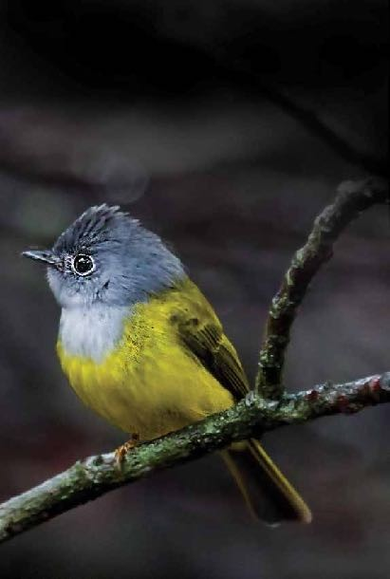

Least Concern (IUCN 3.1)

**Scientific classification** Kingdom: Animalia Phylum: Chordata

Class: Aves

Order: Passeriformes

Family: Stenostiridae

Genus: *Culicicapa*

Species: *C. ceylonensis*

Photograph: Urjit Dwivedi

# 39. Siberian Stonechat

The **Siberian stonechat** or **Asian stonechat** (*Saxicola maurus*) is a recently validated species of the Old World flycatcher family (Muscicapidae). It breeds in the East Palearctic including in easternmost Europe and winters in the Old World tropics.

96

It resembles its closest living relative the European stonechat (*S. rubicola*), but is typically darker above and paler below,with a white rump and whiter underparts with less orange on the breast. The male in breeding plumage has black upperparts and head (lacking the brownish tones of the European stonechat),

a conspicuous white collar, scapular patch and rump, and a restricted area of orange on the throat.

[1]

The female has pale brown upperparts and head, white neck

patches(notafullcollar),and a pale,unstreaked pinkish-

yellow rump. Males in winter plumage are intermediate between summer males and females, with a supercilium resembling the whinchat (*S. rubetra*); from this species and the female it can be distinguished by the full white collar.

In the past, *S. maurus* was usually included in *S. torquatus* as part of the “common stonechat”, but that scientific name nowadays is restricted to the African stonechat.

The wintering range of the migratory bird is from southern Japan south to Thailand and India, and west to northeast Africa.

The Siberian stonechat is insectivorous.

**Common stonechat** is the name used for the *Saxicola* species

***Saxicola torquatus*** when this is treated in its broad sense.

It is, however, now more widely considered to be a superspecies consisting of several related but distinct species, which are outwardly fairly similar but genetically distinct

and replacing each other geographically without significant hybridisation including the Siberian Stonechat.

## Conservation status

Extinct

EX EW

Threatned

CR EN VU

Least Concern

NT LC

97

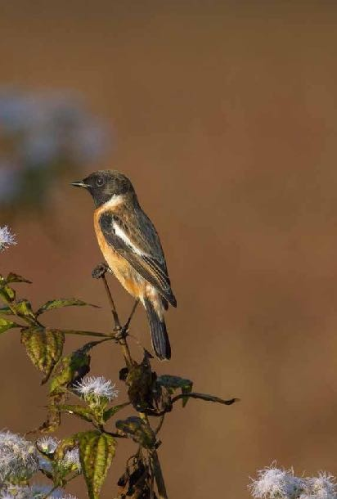

Least Concern (IUCN 3.1)

**Scientific classification** Kingdom: Animalia Phylum: Chordata

Class: Aves

Order: Passeriformes

Family: Muscicapidae

Genus: *Saxicola*

Species: *S. maurus*

Photograph :Urjit Dwivedi

# 40. Oriental Magpie-Robin

The oriental magpie-robin (*Copsychus saularis*) is a small passerine bird that was formerly classed as a member of the thrush family Turdidae, but now considered an Old World flycatcher. They are distinctive black and white birds with a long tail that is held upright as they forage on the ground or perch conspicuously. Occurring across most of the Indian subcontinent and parts of Southeast Asia, they are common birds in urban gardens as well as forests. They are particularly well known for their songs and were once popular as cagebirds. The oriental magpie-robin is the national bird of Bangladesh.

This species is 19 centimetres (7.5 in) long, including the long tail, which is usually held cocked upright. It is similar in shape

to the smaller European robin, but is longer-tailed. The male has black upperparts, head and throat apart from a white shoulder patch. The

underparts and the sides of the long tail are white.

Females are greyish black above and greyish white.Youngbirds have scaly brown upperparts and head.

This magpie-robin is a resident breeder in tropical southern Asia from

Bangladesh, interior India, Sri Lanka and eastern Pakistan east to Indonesia, Thailand, south China, Malaysia, and Singapore

The oriental magpie-robin is found in open woodland and cultivated areas often close to human habitations.

## Conservation status

Extinct

EX EW

Threatned

CR EN VU

Least Concern

NT LC

99

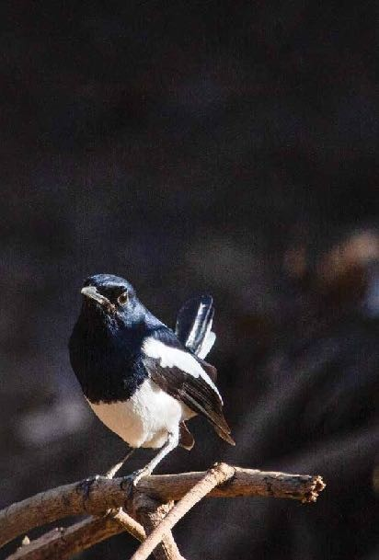

Least Concern (IUCN 3.1)

**Scientific classification**

Kingdom: Animalia

Phylum: Chordata

Class: Aves

Order: Passeriformes

Family: Muscicapidae

Genus: Copsychus

Species: *C. saularis*

Photograph: Urjit Dwivedi

10

# 41. Hodgson’s Redstart

102

The Hodgson's redstart (Phoenicurus hodgsoni) is a species of bird in the family Muscicapidae.

It is found in Bhutan, China, India, Myanmar, and Nepal. Its natural habitat is temperate forests.

It is a winter visitor in the Himalayas.

**Conservation status**

Extinct

EX EW

Threatned

CR EN VU

Least Concern

NT LC

Least Concern (IUCN 3.1)

**Scientific classification** Kingdom: Animalia Phylum: Chordata

Class: Aves

Order: Passeriformes

Family: Muscicapidae

Genus: *Phoenicurus*

Species: *P.auroreus*

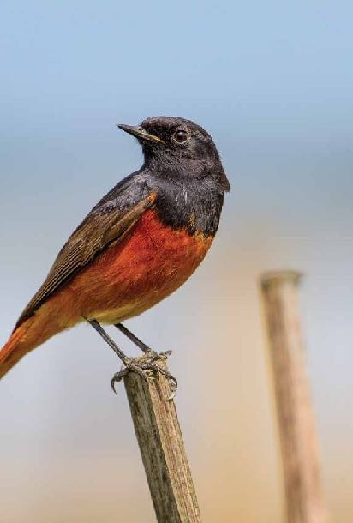

103

# 42. Red-vented Bulbul

The red-vented bulbul (*Pycnonotus cafer*) is a member of the bulbul family of passerines. It is resident breeder across the Indian subcontinent, including Sri Lanka extending east to Burma and parts of Tibet. It has been introduced in many other parts of the world and has established itself in the wild on several Pacific islands including Fiji, Samoa, Tonga and Hawaii. It has also established itself in parts of the United Arab Emirates, Bahrain, the United States and Argentina. It is included in the list of the world’s 100 worst invasive alien species.

The red-vented bulbul is easily identified by its short crest giving the head a squarish appearance. The body is dark brown with a scaly pattern while the head is darker or black. The rump is white while the vent is red. The black tail is tipped in white. Sexes are similar in plumage, but young birds are duller than adults.

The typical call has been transcribed as ginger beer but a number of sharp single note calls likened as pickare also produced. Their alarm calls are usually responded to and heeded by many other species of bird.

This is a bird of dry scrub, open forest, plains and cultivated lands. In its native range it is rarely found in mature forests.

Red-vented bulbuls feed on fruits, petals of flowers, nectar, insects and occasionally geckos. They have also been seen feeding on the leaves of Medicago sativa.

Red-vented bulbuls build their nests in bushes at a height of around 2–3 m (6.6–9.8 ft) two or three eggs is a typical clutch.

Nests are occasionally built inside houses or in a hole in a mud bank.

## Conservation status

Extinct Threatned

EX EW CR EN VU

Least Concern

NT LC

Least Concern (IUCN 3.1)

**Scientific classification** Kingdom: Animalia Phylum: Chordata

Class: Aves

Order: Passeriformes Family: Pycnonotidae Genus: *Pycnonotus*

Species: *P. cafer*

Photograph: Urjit Dwivedi

# 43. Common Myna

The common myna/Indian mynah (*Acridotheres tristis*), sometimes spelled mynah, also sometimes known as “Indian myna”,is a member of the family Sturnidae (starlings and mynas) native to Asia. An omnivorous open woodland bird with a strong territorial instinct, the myna has adapted extremely well to urban environments.

The range of the common myna is increasing at such a rapid rate that in 2000 the IUCN Species Survival Commission declared it one of the world’s most invasive species and one of only three birds in the top 100 species that pose an impact to biodiversity, agriculture and human interests. In particular, the species poses a serious threat to the ecosystems of Australia where it was named “The Most ImportantPest/Problem”.

The range of the common myna is increasing to the extent that in 2000 the IUCN Species Survival Commission declared it among the World’s 100 worst invasive species.

## Conservation status

Extinct

EX EW

Threatned

CR EN VU

Least Concern

NT LC

Least Concern (IUCN 3.1) **Scientific classification** Kingdom: Animalia Phylum: Chordata

Class: Aves

Order: Passeriformes

Family: Sturnidae

Genus: Acridotheres

Species: *A. tristis*

107

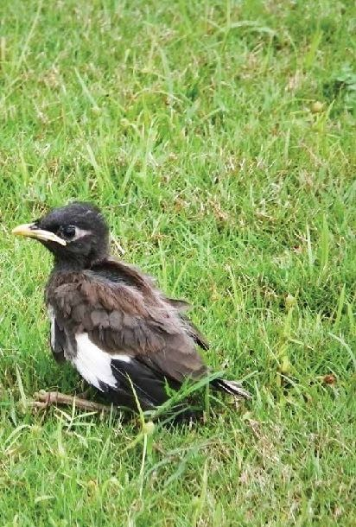

Photograph: Urjit Dwivedi

# 44. Pied Myna

The Pied myna or Asian pied starling (*Gracupica contra*) is a species of starling found in the Indian subcontinent and

Southeast Asia. They are usually found in small groups mainly on the plains and low foothills. They are often seen within cities and villages although they are not as bold as the common myna. They produce a range of calls made up of liquid notes. Several slight plumage variations exist in the populations and about five subspecies are named.

The species has been included in the genus Sturnus and Sturnopastor in the past but recent studies do not support its inclusion within Sturnusleading to the reinstatement of an older genus name Gracupica.

This myna is strikingly marked in black and white and has a yellowish bill with a reddish bill base. The bare skin around the eye is reddish. The upper body, throat and breast are black while the cheek, lores, wing coverts and rump are contrastingly white. The sexes are similar in plumage but young birds have dark brown in place of black. The subspecies vary slightly in plumage, extent of streaking of the feathers and in measurements.

The flight is slow and butterfly-like on round wings. Leucistic individuals have been recorded.

The species is found mainly in the plains but in the foothills up to about 700m above sea level. They are found mainly in areas with access to open water.

## Conservation status

Extinct Threatned

EX EW CR EN VU

Least Concern

NT LC

Least Concern (IUCN 3.1)

109

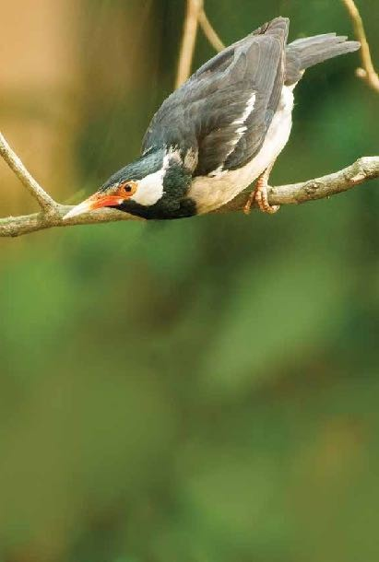

**Scientific classification** Kingdom: Animalia Phylum: Chordata

Class: Aves

Order: Passeriformes

Family: Sturnidae

Genus: *Gracupica*

Species: *G. contra*

Photograph :Urjit Dwivedi

# 45. Jungle Myna

The Jungle Myna (*Acridotheres fuscus*) is a myna, a member of the starling family.

This bird is a common resident breeder in tropical southern Asia from Nepal, Bangladesh, Pakistan, India and Burma east to Indonesia.

This common passerine is typically found in forest and cultivation. The jungle myna builds a nest in hole.Most of the time they build nest in the hole of Palm Tree.The normal clutch is three to sixeggs.

These 23-centimetre (9.1 in) long birds have grey plumage, darker on the head and wings. There are large white wing patches obvious in flight, and a white tail tip. The head has a forehead tuft. The bill and strong legs are bright yellow, and there is no bare skin around eye. The southern Indian race has a blue iris. The sexes are similar, but juveniles are browner.

They are usually found close to water or rice fields.

Like most starlings, the jungle myna is fairly omnivorous, eating fruit, grain and insects.

In many parts of Asia, they are kept as pets. As a result, escaped birds have formed feral populations in many countries such as Taiwan.

## Conservation status

Extinct

EX EW

Threatned

CR EN VU

Least Concern

NT LC

113

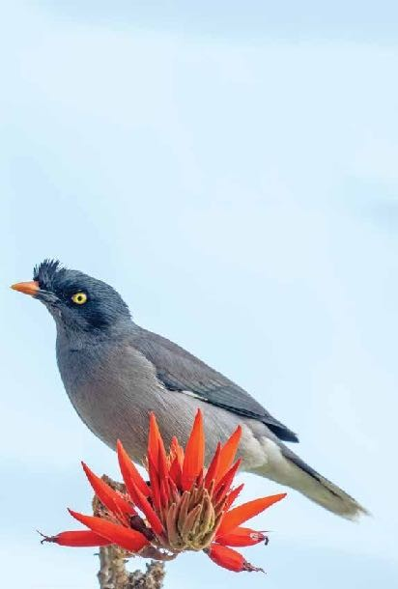

Least Concern (IUCN 3.1)

**Scientific classification**

Kingdom: Animalia

Phylum: Chordata

Class: Aves

Order: Passeriformes

Family: Sturnidae

Genus: Acridotheres

Species: *A. fuscus*

# 46. Chestnut-tailed Starling

The chestnut-tailed starling or grey-headed myna (*Sturnia malabarica*) is amember of the starling family of perching birds. It is a resident or partially migratory species found in wooded habitats in India and Southeast Asia.

The adults have a total length of approximately 20 cm (7.9 in). They have grey upperparts and blackish remiges, but the colour of the remaining plumage depends on the subspecies. In the nominate subspecies and blythii, the underparts (incl. undertail) are rufous, but in nemoricola the underparts are whitish tinged rufous, especially on the flanks and crissum (the undertail coverts surrounding the cloaca). The nominate and nemoricola have a light grey head with whitish streaking (especially on crown and collar region). Both subspecies have white irides and a yellow bill with a pale blue base. The sexes are similar, but juveniles have whitish underparts and just chestnut tips to the tail feathers.

The chestnut-tailed starling’s nest is typically found in open woodland and cultivation. The chestnut-tailed starling builds a nest in hole. The normal clutch is 3-5 eggs.

Like most starlings, the chestnut-tailed starling is fairly omnivorous, eating fruit, nectar and insects. They fly in tight flocks and often rapidly change directions with great synchrony.

## Conservation status

Extinct Threatned

EX EW CR EN VU

Least Concern

NT LC

115

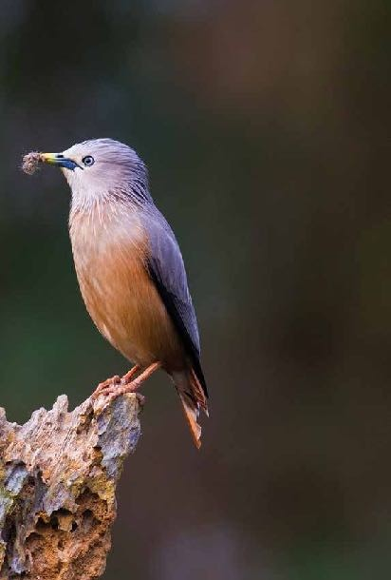

Least Concern (IUCN 3.1)

**Scientific classification** Kingdom: Animalia Phylum: Chordata

Class: Aves

Order: Passeriformes

Family: Sturnidae

Genus: *Sturnia*

Species: *S. malabarica*

Photograph: Urjit Dwivedi

# 47. Common Hill Myna

The common hill myna (*Gracula religiosa*), sometimes spelled “mynah” and formerly simply known as hill myna, is the myna most commonly seen in aviculture, where it is often simply referred to by the latter two names. It is a member of the starlingfamily (Sturnidae), resident in hill regions of South Asia and Southeast Asia.

The common hill myna is often detected by its loud, shrill, descending whistles followed by other calls. It is most vocal at dawn and dusk, when it is found in small groups in forest clearings high in the canopy.

This myna is a resident breeder from Kumaon division in India (80°E longitude) east through Nepal, Sikkim, Bhutanand Arunachal Pradesh, the lower Himalayas, terai and foothills up to 2000 mASL. This myna is almost entirely arboreal, moving in large, noisy groups of half a dozen or so, in tree-tops at the

edge of the forest. It hops sideways along the branch, unlike the characteristic jaunty walk of other mynas. Like most starlings, the hill myna is fairly omnivorous, eating fruit, nectar and insects.

It is increasingly rare in regions of northeastern India due to capture of fledged birds for the illegal pet trade. In the Garo Hills region, however, the locals make artificial nests of a split-bamboo framework covered with grass, and put them up in accessible positions in tall trees in a forest clearing or at the edge of a small village to entice the mynas to breed there. The villagers are thus able to extract the young at the proper time for easy hand-rearing, making common hill myna farming a profitable, small-scale cottage industry. It helps to preserve the environment, because the breeding birds are not removed from the population, while habitat destruction is curtailed because the mynas will desert areas of extensive logging and prefer more natural forest to plantations.

## Conservation status

Extinct Threatned

EX EW CR EN VU

Least Concern

NT LC

Least Concern (IUCN 3.1)

117

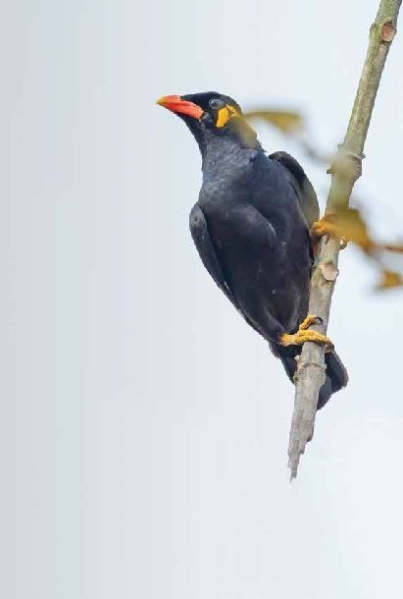

**Scientific classification**

Kingdom: Animalia

Phylum: Chordata

Class: Aves

Order: Passeriformes

Family: Sturnidae

Genus: *Gracula*

Species: *G. religiosa*

Photograph :Urjit Dwivedi

# 48. Black-headed Oriole

The black-headed oriole (*Orioluslarvatus*) is aspecies of bird in the family Oriolidae. It is found in Africa and has a very striking appearance with a bright yellow body, contrasting black head and flesh-coloured beak.

It breeds in much of sub-Saharan Africa from South Sudan and Ethiopia in the north to South Africa in the south.

It inhabits dry tropical forests, especially acacia and broad- leaved woodlands, and dense shrubland areas, where it is more often heard than seen despite the brightness of its plumage.

The black-headed oriole forages in the canopy, feeding on small fruit as well as large insects. The young are fed mostly with caterpillars.

## Conservation status

Extinct Threatned

EX EW CR EN VU

Least Concern

NT LC

Least Concern (IUCN 3.1)

**Scientific classification**

Kingdom: Animalia

Phylum: Chordata

Class: Aves

Order: Passeriformes

Family: Oriolidae

Genus: *Oriolus*

Species: *O. larvatus*

Photograph: Urjit Dwivedi

# 49. Black Drongo

The black drongo (*Dicrurus macrocercus*) is a small Asian passerine bird of the drongo family Dicruridae. It is a common resident breeder in much of tropical southern Asia from southwest Iran through India and Sri Lanka east to southern China and Indonesia. It is a wholly black bird with a distinctive forked tail and measures 28 cm (11 in) in length. It feeds on insects, and is common in open agricultural areas and light forest throughout its range, perching conspicuously on a bare perch

or along power or telephone lines. The species is known for its aggressive behaviour towards much larger birds, such as crows, never hesitating to dive-bomb any bird of prey that invades

its territory. This behaviour earns it the informal name of king crow. Smaller birds often nest in the well-guarded vicinity of a nesting black drongo. Previously grouped along with the African fork-tailed drongo (Dicrurusadsimilis), the Asian forms are now treated as a separate species with several distinct populations.

The black drongo has been introduced to some Pacific islands, where it has thrived and become abundant to the point of threatening and causing the extinction of native and endemic bird species there.

The black drongo is found predominantly in open country and usually perches and hunts close to the ground. They are mostly aerial predators of insects but also glean from the ground or off vegetation. They are found as summer visitors to northeastern Afghanistan and northern Pakistan but are residents from the Indus Valley until Bangladesh and into India and Sri Lanka.

Some populations show seasonal movement that are poorly understood. The black drongo can be found in savannas, fields, and urban habitats.

## Conservation status

Extinct Threatned

EX EW CR EN VU

Least Concern

NT LC

123

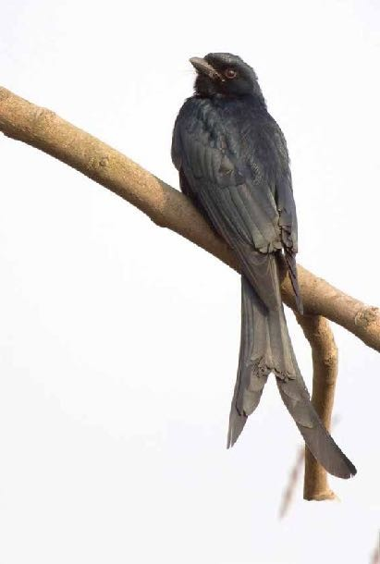

Least Concern (IUCN 3.1)

**Scientific classification**

Kingdom: Animalia

Phylum: Chordata

Class: Aves

Order: Passeriformes

Family: Dicruridae

Genus: Dicrurus

Species: *D. macrocercus*

Photograph: Urjit Dwivedi

# 50. Hair-crested Drongo

The hair-crested drongo (*Dicrurus hottentottus*) is an Asian bird of the family Dicruridae. This species was formerly considered conspecific with Dicrurus bracteatus, for which the name “spangled drongo” – formerly used for both – is now usually reserved.

They have long hair-like feathers springing from forehead, extending over hindcrown and upper back (not in all subspecies). Plumage is black with brightly glossed metallic blue-green colour. Numerous breast spangles are broad and very large. Their neck hackles are long and glossy. Tail is nearly square-ended, inner four pairs of rectrices ending almost at same level as outer pair. Their eyes are reddish-brown or dark brown. Sexes similar, females are duller. Juveniles are browner and less glossed.

It is native from Bangladesh, India and Bhutan through Indochina to China, Indonesia, and Brunei (BirdLife International 2008). Hair- crested drongos move in small flocks and are very noisy.

## Conservation status

Extinct Threatned

EX EW CR EN VU

Least Concern

NT LC

125

Least Concern (IUCN 3.1)

**Scientific classification** Kingdom: Animalia

Phylum: Chordata

Class: Aves

Order: Passeriformes

Family: Dicruridae

Genus: Dicrurus

Species: *D. hottentottus*

# 51. Rufous Treepie

The rufous treepie (*Dendrocitta vagabunda*) is a treepie, native to the Indian Subcontinent and adjoining parts of Southeast Asia.

It is a member of the crow family, Corvidae. It is long tailed and has loud

musical calls making it very conspicuous. It is found commonly in open scrub, agricultural areas, forests as well as urban gardens. Like other corvids it is very adaptable, omnivorous and opportunistic infeeding.

The sexes are alike and the main colour of the body is cinnamon with a black head and the long graduated tail is bluish grey and is tipped in black. The wing has a white patch. The only confusable species is the grey treepie which however lacks the bright rufous mantle.

The range of this species is quite large, covering all of mainland India up to the Himalayas, Pakistan and southeasterly in a broad band into Bangladesh, Burma (Myanmar), Laos, and Thailand in open forest consisting of scrub, plantations and gardens.

The rufous treepie is an arboreal omnivore feeding almost completely in trees on fruits, seeds, invertebrates, small reptiles and the eggs and young of birds; it has also been known to take flesh from recently killed carcasses.

The breeding season in India is April to June. The nest is built in trees and bushes and is usually a shallow platform. There are usually 3-5 eggs laid.

This species has a wide repertoire of calls, but a bob-o- link or ko- tree call is most common.A local name for this bird

kotri is derived from the typical call while other names include

*HandiChancha* and *taka chor* (=”coin thief”).

## Conservation status

Extinct Threatned

EX EW CR EN VU

Least Concern

NT LC

127

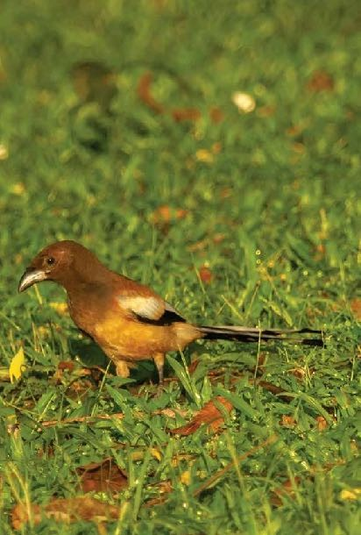

Least Concern (IUCN 3.1)

**Scientific classification** Kingdom: Animalia Phylum: Chordata

Class: Aves

Order: Passeriformes

Family: Corvidae

Genus: *Dendrocitta*

Species: *D. vagabunda*

Photograph: Urjit Dwivedi

# 52. House Crow

The house crow (*Corvussplendens*), also known as the Indian, greynecked, Ceylon or Colombo crow, is a commonbird of the crow family that is of Asian origin but now found in many parts of the world, where they arrived assisted by shipping. It is between the jackdaw and the carrion crow in size (40 cm (16 in) in length) but is slimmer than either. The forehead, crown, throat and upper breast are a richly glossed black, whilst the neck and breast are

a lighter grey-brown in colour.The wings, tail and legs are black. There are regional variations in the thickness of the bill and the depth of colour in areas of the plumage.

It has a widespread distribution in southern Asia, being native to Nepal, Bangladesh, India, Pakistan, Sri Lanka, ,Maldives, and Laccadive Islands, SouthWestThailand and coastal southern Iran. It was introduced to East Africa around Zanzibar (about 1897) and Port Sudan.

It is associated with human settlements throughout its range, from small villages to large cities. In Singapore, there was a density of 190 birds/km2 in 2001 with efforts to suppress the population in planning.

Due to a human population explosion in the areas it inhabits, this species has also proportionately multiplied. Being an omnivorous scavenger has enabled it to thrive in such circumstances.

House crows feed largely on refuse around human habitations, small reptiles and mammals, and other animals such asinsects and other small invertebrates, eggs, nestlings, grain and fruits.

They are highly opportunistic birds and given their omnivorous diet, they can survive on nearly anything that is edible. These birds can be seen near marketplaces and garbage dumps, foraging for scraps. They have also been observed to eat sand after feeding on carcasses.

House crows roost communally near human habitations and often over busy streets. A study in Singapore found that the preferred roost sites were in well-lit areas with a lot of human

activity, close to food sources and in tall trees with dense crowns that were separated from other trees.

## Conservation status

Extinct Threatned

EX EW CR EN VU

Least Concern

NT LC

129

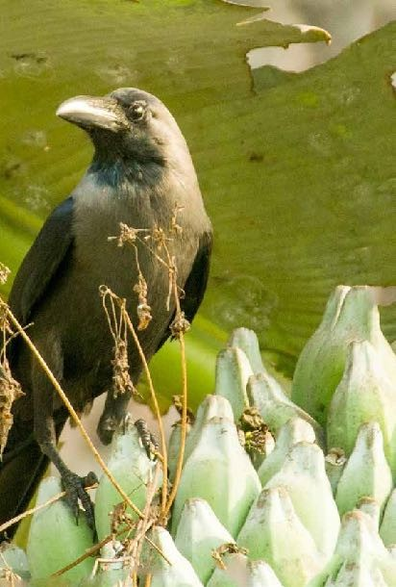

Least Concern (IUCN 3.1)

**Scientific classification** Kingdom: Animalia Phylum: Chordata

Class: Aves

Order: Passeriformes

Family: Corvidae

Genus: *Corvus*

Species: *C. splendens*

Photograph: Urjit Dwivedi

# 53. House Sparrow

The house sparrow (*Passer domesticus*) is a bird of the sparrow family Passeridae, found in most parts of the world. A small bird, it has a typical length of 16 cm (6.3 in) and a mass of 24–39.5

g (0.85–1.39 oz). Females and young birds are coloured pale brown and grey, and males have brighter black, white, and brown markings. One of about 25 species in the genus Passer, the house sparrow is native to most of Europe, the Mediterranean Basin, and much of Asia. Its intentional or accidental introductions to many regions, including parts of Australia, Africa, and the Americas, make it the most widely distributed wild bird.

The house sparrow is strongly associated with human habitations, and can live in urban or rural settings. Though found in widely varied habitats and climates, it typically avoids extensive woodlands, grasslands, and deserts away from human development. It feeds mostly on the seeds of grains and weeds, but it is an opportunistic eater and commonly eats insects and many other foods. Its predators include domestic cats, hawks, owls, and many other predatory birds and mammals.

Because of its numbers, ubiquity, and association with human settlements, the house sparrow is culturally prominent. It is extensively, and usually unsuccessfully, persecuted as an agricultural pest. It has also often been kept as a pet, as well

as being a food item and a symbol of lust, sexual potency, commonness, and vulgarity. Though it is widespread and abundant, its numbers have declined in some areas. The animal’s conservation status is listed as least concern on the IUCN Red List.

## Conservation status

Extinct

EX EW

Threatned

CR EN VU

Least Concern

NT LC

133

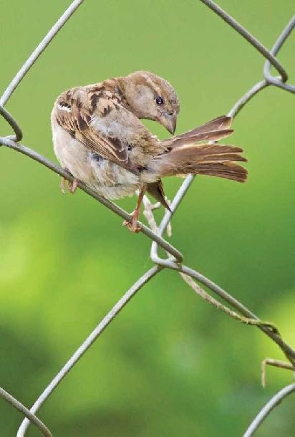

Least Concern (IUCN 3.1)

**Scientific classification**

Kingdom: Animalia

Phylum: Chordata

Class: Aves

Order: Passeriformes

Family: Passeridae

Genus: *Passer*

Species: *P.domesticus*

Photograph: Urjit Dwivedi

# 54. Oriental White-eye

The Oriental white-eye (*Zosterops palpebrosus*) is a small passerine bird in the white-eye family. It is a resident breeder in open woodland in tropical Asia, east from the Indian subcontinent to Southeast Asia, extending to Indonesia and Malaysia. They forage in small groups, feeding on nectar and small insects.

They are easily identified by the distinctive white eye- ring and overall yellowish upperparts. Several populations of this widespread species are named subspecies and some have distinctive variations in the extent and shades of yellows in their plumage.

This bird is small (about 8–9 cm long) with yellowish olive upper parts, a white eye ring, yellow throat and vent. The belly is whitish grey but may have yellow in some subspecies. The sexes look similar.

The species is found in a wide range of habitats from scrub to moist forest.

## Conservation status

Extinct Threatned

EX EW CR EN VU

Least Concern

NT LC

Le st Conc rn (IUCN 3.1)

**Scientific classification**

Kingdom: Animalia

Phylum: Chordata

Class: Aves

Order: Passeriformes

Family: Zosteropidae

Genus: *Zosterops*

Species: *Z. palpebrosus*

135

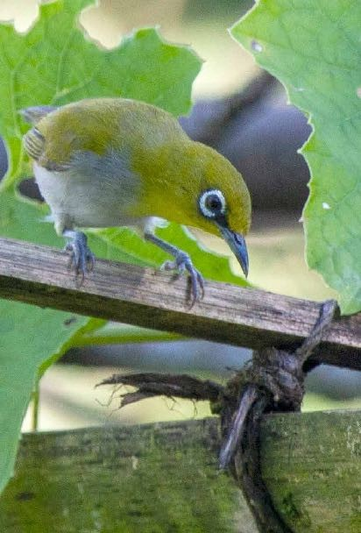

# 55. Scaly-breasted Munia

The scaly-breasted munia or spotted munia (*Lonchura punctulata*), known in the pet trade as nutmeg mannikin or spice finch, is a sparrow-sized estrildid finch native to tropical Asia. The species has 11 subspecies across their range and differ slightly in size and colour.

This munia eats mainly grass seeds apart from berries and small insects. They forage in flocks and communicate with soft calls and whistles. The species is highly social and may sometimes roost with other species of munias.

The species is endemic to Asia and occurs from India and Sri Lanka

east to Indonesia and the Philippines (where it is called mayangpakíng). It has been introduced into many other parts of the world and feral populations have established in Puerto Rico and Hispaniola as well as parts of Australia and the United States of America. The bird is listed as of Least Concern by the International Union for Conservation of Nature (IUCN).

The scaly-breasted munia feeds mainly on seeds but also eats small berries. Like some other munias, they may also feed on algae, a rich protein source, prior to the breeding season.

The ease of maintaining these birds in captivity has made them popular for studying behavior and physiology.

Scaly-breasted munias are found in a range of habitats but are usually close to water and grassland. In India, they are especially common in paddy fields where they are considered a minor pest on account of their feeding on grain. They are found mainly on the plains, but can be observed in the foothills of the Himalayas.

## Conservation status

Extinct Threatned

EX EW CR EN VU

Least Concern

NT LC

137

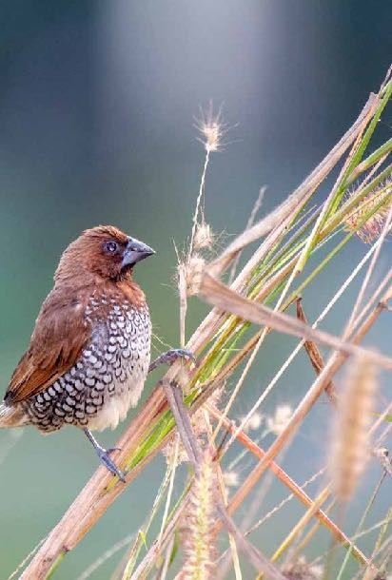

Genus: *Lonchura*

Least Concern (IUCN 3.1)

**Scientific classification** Kingdom: Animalia Phylum: Chordata

Class: Aves

Order: Passeriformes

Family: Estrildidae

Species: *L. punctulata*

Photograph: Urjit Dwivedi

# 56.Scarlet Backed Flowerpecker

The scarlet-backed flowerpecker(*Dicaeumcruentatum*)isa species of passerine bird in the flowerpecker family Dicaeidae. Sexually dimorphic, the male has navy blue upperparts with a bright red streak down its back from its crown to its tail coverts, while the female and juvenile are predominantly olive green.

It is found in subtropical or tropical moist lowland forests and occasionally gardens in a number of countries throughout South and East Asia.

Measuring 9 cm (3.5 in) and weighing 7 to 8 grams (0.25 to 0.28 oz), the scarlet-backed flowerpecker is a small bird with a short tail. It exhibits sexual dimorphism. The male has a navy blue face, wings and tail, with a broad bright red stripe from its crown to its upper tail coverts. The female is predominantly olive green with a black tail and scarlet upper tail coverts and rump. Both sexes have creamy white underparts, black eyes and legs, and a dark grey arched bill. The juvenile has plumage similar to the female but has an orange bill and lacks the bright red rump.

It is found in Bangladesh, Bhutan, Brunei, Cambodia, China, India, Indonesia, Laos, Malaysia, Myanmar, Nepal, Singapore, Thailand, and Vietnam. No global population studies have been undertaken; it is thought to be common throughout most of its range particular in Thailand, although it is considered rare in Bhutan and Nepal. It is found up to 1000 m (3500 ft), in subtropical or tropical moist lowland forests, wooded areas and gardens. In the north of its range, it is found in southeastern China to Fujian (as the subspecies Dicaeum c. cruentatum).

It

has been recorded from both native and plantation forest in West Bengal in India.

## Conservation status

Extinct Threatned

EX EW CR EN VU

Least Concern

NT LC

141

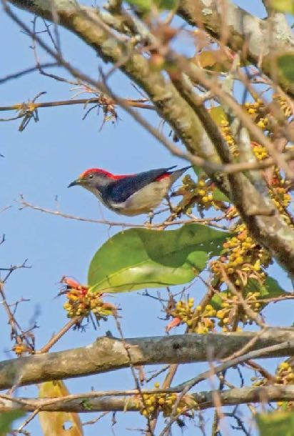

Least Concern (IUCN 3.1)

**Scientific classification**

Kingdom: Animalia

Phylum: Chordata

Class: Aves

Order: Passeriformes

Family: Dicaeidae

Genus: Dicaeum

Species: *D. cruentatum*

Photograph: Urjit Dwivedi

# 57. Crimson Sunbird

The Crimson Sunbird(*Aethopygasiparaja*)is a species of bird in the sunbird family which feed largely on nectar, although they will also take insects, especially when feeding the young. Flight is fast and direct on their short wings. Most species can take nectar by hovering like a hummingbird, but usually perch to feed most of the time.

The crimson sunbird is a resident breeder in tropical southern Asia from India, through Bangladesh and Myanmar to Indonesia. Two or three eggs are laid in a suspended nest in a tree. This species occurs in forest and cultivated areas.

Crimson sunbirds are tiny, only 11 cm long. They have medium- length thin down-curved bills and brush-tipped tubular tongues, both adaptations to their nectar feeding.

The adult male has a crimson breast and maroon back. The rump is yellow and the belly is olive. The female has an olive- green back, yellowish breast and white tips to the outer tail feathers.

In most of the range, males have a long green-blue tail, but A.s. nicobarica of the Nicobar Islands and the former subspecies A. vigorsii (Western crimson sunbird) of theWestern Ghats of India lack the long central tail feathers. Their call is chee-cheewee.

## Conservation status

Extinct Threatned

EX EW CR EN VU

Least Concern

NT LC

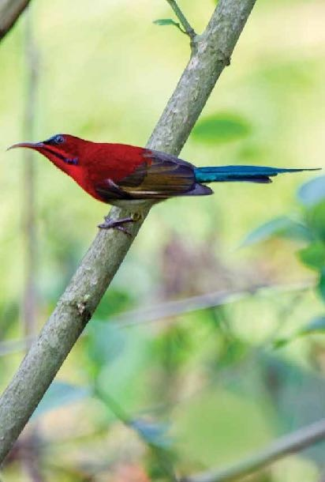

Least Concern (IUCN 3.1)

**Scientific classification**

# 58.Purple Sunbird

The **purple sunbird** (*Cinnyrisasiaticus*) is a small bird in the sunbird family found mainly in South and Southeast Asia but extending west into parts of the Arabian peninsula. Like other sunbirds they feed mainly on nectar, although they will also take insects, especially when feeding young. They have a fast and direct flight and can take nectar by hovering like a hummingbird but often perch at the base of flowers. The males can appear all black in harsh sunlight but the purple iridescence is visible on closer observation or under good light conditions. Females are olive above and yellowish below.

This small sunbird has a relatively short bill, a dark and short square ended tail with distinctive sexual dimorphism. Less than 10 cm long they have a down-curved bill with brush-tipped tubular tongues that aid in nectar feeding. The male is glossy metallic bluish to purplish black on the upper parts with the wings appearing dark brown. The breeding male also has under parts

of the same purplish black, but non-breeding males may show a central streak of black on yellow under parts. In the breeding plumage, the male can be confused with the syntopic Loten’s

sunbird which has a long bill and a distinctive broad maroon band on the breast. Breeding males will sometimes show their yellow pectoral tufts in displays. There is a patch of bright blue on the shoulder of breeding males. The maroon shine on the feathers of the collar around the neck is visible mainly during the breeding seasons.

Females are olive brown above with a yellowish underside.

There is a pale supercilium beyond the eye. There is a darkish eye stripe. The throat and breast are yellow, becoming pale towards the vent. The outer tail feathers are tipped in white both in the male and female.

They are seen in pairs or small groups and aggregations may be found in gardens with suitable flowers. They feed mainly on nectar but also take fruits and insects. Groups of as many as 40 to 50 individuals have sometimes been noted.

The species is distributed widely from West Asia through the Indian subcontinent and into Southeast Asia. They are resident birds in most parts of their range and do not move large distances. They are found in thin forest and garden land ,including those in dense urban areas.

## Conservation status

Extinct Threatned

EX EW CR EN VU

Least Concern

NT LC

145

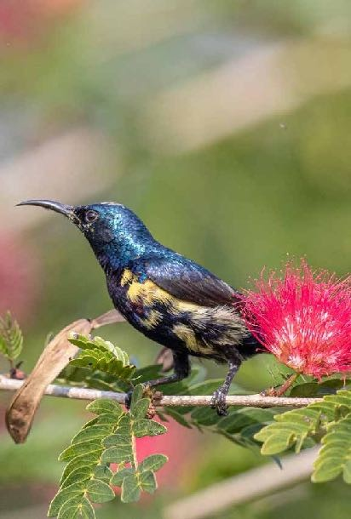

Least Concern (IUCN 3.1)

**Scientific classification** Kingdom: Animalia Phylum: Chordata

Class: Aves

Order: Passeriformes

Family: Nectariniidae

Genus: *Cinnyris*

Species: *C. asiaticus*

Photograph: Urjit Dwivedi

# 59. Little Spiderhunter

The little spiderhunter (*Arachnothera longirostra*) is a species of long- billed nectar-feeding bird in the family Nectariniidae found in the moist forests of South and Southeast Asia. Unlike typical sunbirds, males and females are very similar in plumage. They are usually seen in ones or twos and frequently make a tzeck call and are most often found near flowering plants, where they obtain nectar.

The distinctive long beak set it apart from other sunbirds. The sexes are alike except for a paler base to lower mandible in the female. Male has all black beak They are found close to their favourite nectar bearing trees, often species of wild Musaceae or flowers in gardens.They have a buzzy zick-zick call that is made regularly when disturbed or when foraging. The song is series of rapid chipping notes and these can go on for long periods

The species is found in Bangladesh, Bhutan, Brunei, Cambodia, China, India, Indonesia, Laos, Malaysia, Myanmar, Nepal, Philippines, Thailandand Vietnam.

Its natural habitats are subtropical or tropical moist lowland forests, subtropical or tropical mangrove forests, and subtropical or tropical moist montane forests. It is usually found below the canopy. They are also found in gardens, attracted especially by flowers that yield nectar.

## Conservation status

Extinct

EX EW

Threatned

CR EN VU

Least Concern

NT LC

147

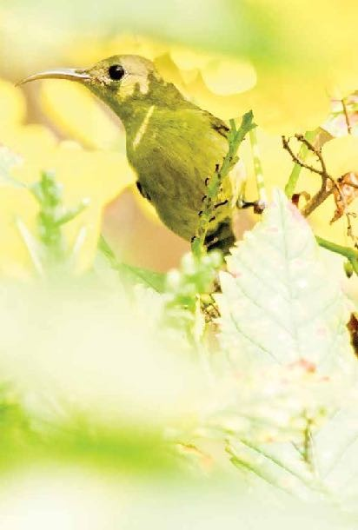

Least Concern (IUCN 3.1)

**Scientific classification**

Kingdom: Animalia

Phylum: Chordata

Class: Aves

Order: Passeriformes

Family: Nectariniidae

Genus: Arachnothera

Species: *A. longirostra* Photograph: Urjit Dwivedi